APPLICATION OF RANDOM FOREST MODEL FOR MILK QUALITY CLASSIFICATION AND PROTOTYPE SYSTEM DEVELOPMENT IN UGANDAN DAIRY PROCESSING PLANTS

BEHANGANA EMMANUEL
23/BSU/MBIT/1587

A DISSERTATION SUBMITTED TO THE FACULTY OF AGRICULTURE
ENVIRONMENTAL SCIENCE AND TECHNOLOGY IN PARTIAL
FULFILLMENT OF THE REQUIREMENTS FOR THE
AWARD OF MASTER OF BUSINESS IN
INFORMATION TECHNOLOGY OF
BISHOP STUART UNIVERSITY

June, 2026

Declaration
I, Behangana Emmanuel, hereby declare that this dissertation titled "Application of Random Forest Model for Milk Quality Classification and Prototype System Development in Ugandan Dairy Processing Plants" is my original work and has not been submitted for any degree award in any other university or institution of higher learning.
All sources of information and materials used in this research have been duly acknowledged through proper citations and references.

Where collaborative work or assistance was received, it has been explicitly stated and acknowledged in the appropriate sections of this thesis.

_________________ 13/06/2026
Behangana Emmanuel DATE

Approval
I hereby certify that this research thesis entitled "Application of Random Forest Model for Milk Quality Classification and Prototype System Development in Ugandan Dairy Processing Plants" has been prepared and submitted by Behangana Emmanuel under my supervision. I approve it for submission to the Faculty of Agriculture, Environment Science, and Technology, Bishop Stuart University, in fulfillment of the requirements for the award of Master of Business in Information Technology.

______________________________
Dr. Katushabe Calorine (PhD)
Department of Computing, Library and Information Technology,
Faculty of Agriculture, Environmental Sciences, and Technology
Bishop Stuart University

______________________________
Mr. Nkuuhe Douglas
Faculty of Agriculture, Environmental Sciences, and Technology
Bishop Stuart University

Acknowledgement
I am deeply grateful to my supervisors Dr. Katushabe Calorine (PhD) and Mr. Nkuuhe Douglas for the invaluable guidance, constructive criticism, and continuous support provided throughout the entire research process. Their academic insight, patience, and commitment greatly shaped the direction and quality of this work. Without their mentorship, the successful completion of this thesis would not have been possible.
I extend my sincere appreciation to the lecturers and staff of the Department of Computing, Library, and Information Technology for the knowledge, encouragement, and academic environment that enabled me to undertake this study. I am also thankful to the university administration for providing the necessary institutional support and resources required during the course of this research.
I acknowledge with gratitude the cooperation of all respondents, institutions, and organizations that participated in this study. Their willingness to share information, experiences, and data was essential to the successful execution of the research and significantly contributed to the validity of the findings.
Special thanks go to my family and friends for their unwavering moral support, encouragement, and understanding throughout my academic journey. Their prayers, motivation, and belief in me provided the strength and determination needed to complete this work.
Finally, I thank God Almighty for the gifts of life, wisdom, strength, and perseverance throughout this academic endeavor. His guidance and grace sustained me through every stage of this research.

Dedication
This thesis is dedicated to God Almighty, whose guidance, wisdom, and grace sustained me throughout this academic journey, and to my family for their unwavering support, prayers, encouragement, and sacrifices. I also dedicate this research to the students of Bishop Stuart University who entrusted me with the responsibility of serving as their Guild President in 2021-2022. Their confidence in my leadership inspired my pursuit of postgraduate studies and motivated this academic journey, and this work stands as a reflection of the opportunity they gave me to lead, serve, and grow.
Abstract
Milk quality remains a major concern in Ugandan dairy processing plants due to post-harvest losses, inconsistent handling practices, and the continued reliance on manual quality assessment methods that are often slow, subjective, and insufficient for timely decision-making. These challenges are particularly significant in key dairy-producing districts such as Mbarara and Kiruhura, where maintaining milk quality is essential for food safety, market competitiveness, and public health. This study was undertaken to develop and evaluate a Random Forest model for milk quality classification and to integrate the model into a prototype system to support decision-making in Ugandan dairy processing plants.
A standards-bounded synthesized dataset comprising 1,500 samples was constructed using East African raw milk quality standards EAS 67:2023 after access to operational plat data proved restricted. The dataset included 11 physicochemical, microbiological, and sensory attributes, namely pH, temperature, taste, odor, fat content, titratable acidity, protein content, lactose content, Total plate count, somatic cell count, and color.
Data preprocessing was undertaken to prepare the dataset for machine learning classification. Several classification models were evaluated during experimentation, including Support Vector Machine, Artificial Neural Network, XGBoost, and Random Forest. Among the evaluated models, Random Forest achieved the best overall classification performance and was therefore selected as the principal model for the study. The selected model was then integrated into a web-based prototype interface developed to classify milk quality into low, medium, and high categories.
The findings showed that the Random Forest model provides a practical approach for supporting milk quality classification in dairy processing environments where rapid and consistent interpretation of quality indicators is required. The selected model was subsequently integrated into a prototype web-based system named DairyIQ which offers an interactive interface through which plant operators can enter quality-related parameters and obtain classification outputs that may support routine quality assessment.
The study demonstrates that machine learning can provide a practical foundation for digital milk quality screening and decision support in Ugandan dairy processing contexts. However, because the model was validated using a synthesized standards-aligned dataset rather than real-time operational records, the findings should be interpreted as a proof of concept. Future work should therefore focus on validating the model using field data from dairy processing plants and refining the prototype for operational deployment.

List of Acronyms
ML Machine Learning
AI Artificial Intelligence
GS Google Scholar
Py Python Programming
Qt Quick Designer Tool
SVM Support Vector Machine
ANN Artificial Neural Networks
PCA Principal Component Analysis
RF Random Forest
MAE Mean Absolute Error
RMSE Root Mean Squared Error
KNN K-Nearest Neighbors
DW-KNN Distance -Weighted KNN
GBM Gradient Boosting Machine
E-Nose Electronic Nose
LDA Linear Discriminant Analysis
AdaBoost Adaptive Boosting
MCCs Milk Collection Centers
DDA Dairy Development Authority

List of Figures

Figure 1: Model Evaluation 48
Figure 2: Random Forest Quality Classification Matrix 50
Figure 3: DairyIQ Data Flow Diagram 52
Figure 4: Data Loading and Feature Definition 65
Figure 5: Data Validation and Sensory Encoding 66
Figure 6: Results Graph 66
Figure 7: Parameter Data Inputs 68
Figure 8: Sample Results 69
Figure 9: District Volume Performance 69
Figure 10: District Quality Performance 70
Figure 11: District Performance: Volume Vs. Quality 70

List of Tables
Table 1: Strengths and Weaknesses of SVM 28
Table 2: Strengths and Weaknesses of Random Forest (RF) 30
Table 3: Strengths and Weaknesses of Artificial Neural Networks (ANN) 32
Table 4: Strengths and Weaknesses of KNN and DW-KNN 34
Table 5: Strengths and Weaknesses of GBM/XGBoost 37
Table 6: Strengths and Weaknesses of E-Nose + ML Models 38
Table 7: Comparative Summary of ML Models for Milk Quality Prediction 40
Table 8: Analysis of Key Milk Quality Features and Standards 52
Table 9: Feature Correlation Matrix 54
Table 10: Comparative Performance of ML Models 61

Table of Contents
Declaration 2
Approval 3
Acknowledgement 4
Dedication 5
List of Acronyms 7
List of Figures 8
List of Tables 9
Chapter One 14
Introduction 14
1.1 Introduction 14
1.2 Background to the Study 15
1.3 Problem Statement 16
1.4 General Objective 17
1.5 Specific Objectives 18
1.6 Research Questions 18
1.7 Significance of the Study 18
1.8 Scope of the Study 19
1.8.1 Content Scope 19
1.8.2 Geographical Scope 19
1.8.3 Time Scope 19
Literature Review 20
2.1 Introduction 20
2.2 Data Collection and Feature Selection 21
2.3 Model Development and Evaluation 22
2.3.1 Model Validation and User Interface Development 23
2.3.2 Support Vector Machines (SVM) in Milk Quality Classification 23
2.3.3 Random Forest (RF) in Milk Quality Classification 25
2.3.4 Comparative Summary of Machine Learning Models for Milk 27
2.3.5 K-Nearest Neighbors (KNN and Distance-Weighted KNN) in Milk Quality Classification 29
2.3.6 Gradient Boosting Machines (GBM) and XGBoost in Milk Quality classification 31
2.3.7 Sensor-Integrated Machine Learning Models: Electronic Nose (E-Nose) with ML Algorithms 33
2.3.8 Comparative Summary of Machine Learning Models for Milk Quality Classification 35
2.3.9 Model Selection and Justification 36
2.3.10 Model Selection for the Current Study 37
Chapter Three 41
Methodology 41
3.1 Data Collection 41
3.1.1 Data Sources 41
3.1.2 Data Collection Methods 42
3.5 Data Cleaning 46
3.6 Data Transformation 46
3.7 Feature Selection 47
3.8 Machine Learning Model Development 48
3.8.1 Model Selection 48
3.8.2 Model Training 48
3.9 Model Evaluation 48
3.9.1 Performance Metrics 49
3.9.2 Cross-Validation 50
3.10 Model Validation 51
3.11 User Interface Development 51
3.11.1 Interface Design 51
3.11.2 Implementation 53
3.12 Technical Tools and Software 53
3.12.1 Data Processing Tools 53
3.12.2 Machine Learning Frameworks 54
3.12.3 User Interface Development: 54
User Interface Development 54
3.13. Limitation: 55
Chapter Four 56
RESULTS AND DISCUSSIONS 56
4.1 Introduction 56
4.2 Objective One Results 56
4.2.1 Results, Analysis, and Discussions from the Literature 56
4.2.2 Results from Data Collection 58
4.3 Objective Two Results 60
4.3.1 Model Formulation and Design 60
4.3.2 Model Architecture 61
4.3.3 System Wireframes 61
4.4 Objective Three Results 62
4.4.1 Parameters Used for Testing the Model 62
4.4.2 Validation of the Model 63
4.4.3 Code Snippets 64
4.4.4 System Demonstration With User Inputs and Outputs 67
4.5 Operational Implications and Interventions 70
4.6 Limitations 71
Chapter Five 72
Conclusion and Recommendation 72
5.1 Introduction 72
5.2 Discussion 72
5.2.1 Synthesis of Findings 72
5.2.2 Broader Implications 73
5.3 Conclusion 74
5.4 Experiences and Skills Gained 74
5.4.1 Technical Skills 74
5.4.2 Research and Analytical Skills 75
5.5 Recommendations 75
5.6 Future Work 76
Reference 77

Chapter One

Introduction

1.1 Introduction
The dairy sector plays a significant role in Uganda’s economy through its contribution to household income, food security, employment, and agro-industrial development [13], [14]. Milk and milk products are important to nutrition and livelihoods, especially in the cattle corridor districts where dairy production is a major economic activity. However, the sector continues to face challenges related to milk quality deterioration during handling, transportation, collection, and processing. These challenges reduce the value of milk, expose consumers to health risks, and limit the competitiveness of dairy enterprises in domestic and export markets [15], [20].
In response to such challenges, machine learning has emerged as a useful data-driven approach for solving prediction and decision-support problems. In supervised machine learning, algorithms learn patterns from historical data containing input features and known output labels and then use those learned patterns to predict the class of new observations [23]. Common supervised machine learning techniques include decision trees, support vector machines, artificial neural networks, and ensemble methods such as Random Forest. These techniques are particularly useful where large amounts of structured data are available and where human judgment alone may produce inconsistent outcomes.
Within machine learning, this study was concerned with a classification problem. A classification problem raised when the aim is to assign observations to predefined discrete categories rather than to predict continuous numerical values. In the context of milk quality assessment, the task was to use measured milk characteristics such as pH, temperature, taste, odor, fat content, titratable acidity, protein content, lactose content, Total plate count, somatic cell count, and color to classify milk into quality classes such as low, medium, or high quality. This made the problem suitable for supervised classification techniques because the output variable consists of categorical class labels.
Although traditional milk quality assessment methods are still used in many Ugandan dairy processing contexts, they are often time-consuming, operator-dependent, and less suitable for consistent decision-making in increasingly complex supply chains [3]. This created the need not only for an accurate classification model but also for a practical system through which dairy personnel can interact with the model and use its outputs in routine operations.
For that reason, the study extended beyond model development to the design of a system prototype. A prototype is an early representation of an intended software system that is used to demonstrate functionality, refine user requirements, and guide eventual implementation. It ranged from a low-fidelity conceptual design to a high-fidelity interactive interface that resembles the final system. In this study, the prototype system served as a user-oriented decision-support tool through which milk quality data was entered, classification results were displayed, and the practical applicability of the model was assessed in the dairy processing environment.
This study applied supervised machine learning to the problem of milk quality classification in Ugandan dairy processing plants, with particular focus on the Random Forest model. Random Forest is emphasized because of its suitability for structured tabular data, its robustness, and its usefulness in classification tasks. The study further integrated the selected model into a prototype system so as to demonstrate how machine learning outputs can be translated into a practical decision-support tool for dairy quality assessment. By combining algorithmic classification with prototype system development, the study addresses both classification performance and practical usability in the Ugandan dairy processing context.

1.2 Background to the Study
Uganda is one of the leading milk-producing countries in East Africa, and the dairy industry has expanded steadily over the years [25]. Major dairy-producing districts such as Mbarara and Kiruhura contribute substantially to national milk output and serve as important centers for milk collection, transportation, and processing. Despite this growth, maintaining milk quality remains a persistent challenge due to inadequate cold-chain management, delays in transportation, poor handling practices, contamination risks, and variability in testing procedures [30]. These problems contribute to quality losses along the dairy value chain and affect processors, traders, farmers, and consumers alike.
Milk quality is commonly determined using a combination of physicochemical and sensory indicators. In this study, the variables considered include pH, temperature, taste, odor, fat content, titratable acidity, protein content, lactose content, Total plate count, somatic cell count, and color. These variables are important because they capture characteristics associated with freshness, contamination, spoilage, adulteration, and market acceptability [18]. In practical settings, however, interpreting such indicators consistently can be difficult when assessment depends primarily on manual judgment. This creates a need for analytical approaches capable of learning patterns from existing quality records and generating consistent classification outcomes.
Globally, machine learning has increasingly been applied in agriculture and food quality management to support classification, quality monitoring, and decision-making [24]. In the context of dairy quality assessment, machine learning models can analyze multiple quality attributes simultaneously and identify relationships that may not be easily detected through manual inspection alone. Within the present study, different machine learning models were evaluated, and Random Forest emerged as the best-performing model among the tested alternatives. Its selection for this study is therefore grounded in empirical performance within the dataset used, as well as its suitability for classification tasks involving structured tabular data.
Beyond algorithmic performance, there was also a practical need to translate model outputs into a usable operational tool. A machine learning model has limited value in practice if it is not presented through an interface that supports end-user interaction. For this reason, the study included prototype system development as an integral component. The prototype intended to provide an interactive means through which users can input milk quality variables results from the laboratory and obtain classification outputs to support routine decision-making in dairy processing plants.

1.3 Problem Statement
Milk quality management remains a major challenge in Ugandan dairy processing plants despite the sector's importance to national development and household livelihoods [26]. The study in [28] highlights that even when farm-level practices improve, the broader value chain, including processing and collection centers, fails to meet hygiene standards, with only 13.3% of samples at collection centers meeting criteria for human consumption [26]. Furthermore, the Ugandan dairy sector contributes roughly 4.2% to the national GDP and 17% to the agricultural GDP, underscoring its role in national development and household livelihoods.
In many operational settings, milk quality assessment still relies on conventional procedures that may be slow, subjective, and insufficiently consistent for effective classification and decision-making. As a result, poor-quality milk may enter processing channels, while acceptable milk may be rejected or downgraded due to inconsistent assessment practices. These weaknesses contribute to economic losses, undermine consumer confidence, and create food safety concerns within the dairy value chain [36].
Although machine learning methods have shown immense potential in food quality analysis, there remains a prominent practical gap in the application of context-appropriate classification models and user-oriented prototype systems for milk quality assessment in Ugandan dairy processing environments [37]. Currently, regional milk collection centers and processing nodes in Uganda still heavily rely on manual, rudimentary testing mechanisms like lactometers and alcohol stability tests, leaving a severe deficiency in digital, user-friendly classification frameworks tailored for local operators [28], [29]. In particular, there was limited evidence of simple, usable machine learning-based tools designed to support classification of milk quality using locally relevant quality indicators. This gap was especially important in major dairy-producing areas such as Mbarara and Kiruhura, where routine and reliable quality assessment is essential for operational efficiency and product safety.
Accordingly, this study addressed the problem by developing and evaluating a Random Forest model for milk quality classification and by integrating the selected model into a prototype system intended to support milk quality decision-making in Ugandan dairy processing plants.
This study was motivated by the need to develop a practical and context-relevant machine learning solution for milk quality classification in Uganda. By grounding the classification process in recognized East African milk quality standards and integrating the predictive model into a prototype system, the research focused to bridge the gap between algorithmic performance and operational relevance in dairy processing plants.
Conceptually, the study treats milk parameters such as pH, temperature, taste, odor, fat content, titratable acidity, protein content, lactose content, Total plate count, somatic cell count, and color as predictors variables that jointly influence the final quality class assigned by the model. The Radom Forest algorithm serves as the analytical mechanism through which these attributes are processed to generate a classification outcome of high, moderate or low milk quality.

1.4 General Objective
The general objective of this study was to develop and evaluate a Random Forest model for milk quality classification and to integrate it into a prototype system for use in Ugandan dairy processing plants.

1.5 Specific Objectives
- To identify the key milk quality features required for classification of milk into defined quality categories.
- To develop and evaluate a Random Forest model for milk quality classification using appropriate classification metrics.
- To design and implement a prototype system that applies the Random Forest model to support milk quality classification in Ugandan dairy processing plants.
- To assess the usability and practical applicability of the prototype system in supporting milk quality assessment.

1.6 Research Questions
- What key milk quality features should be identified and preprocessed for effective milk quality classification?
- How effectively can the Random Forest model classify milk quality into the defined categories?
- How can a prototype system be designed and implemented to apply the Random Forest model for milk quality classification in dairy processing plants?
- How usable and practically applicable is the prototype system for supporting milk quality assessment by plant operators?

1.7 Significance of the Study
This study is significant to dairy processors because it provides a data-driven approach for improving consistency in milk quality classification. By supporting more systematic interpretation of milk quality indicators, the study has the potential to reduce uncertainty in assessment decisions and improve quality control practices within dairy processing operations.
The study is also significant to farmers, consumers, and regulatory stakeholders. Improved classification of milk quality may contribute to better handling of milk entering the value chain, enhanced food safety, and greater confidence in dairy products. In broader terms, the study may support efforts aimed at improving efficiency, product quality, and competitiveness in Uganda's dairy sector.
From an academic perspective, the study contributes to the growing body of knowledge on the application of machine learning in agricultural and food systems within developing-country contexts. It further demonstrates how machine learning classification can be linked to prototype system development to produce practically relevant decision-support tools rather than purely theoretical models.

1.8 Scope of the Study

1.8.1 Content Scope
The study focused on milk quality classification using selected milk quality indicators, namely pH, temperature, taste, odor, fat content, titratable acidity, protein content, lactose content, Total plate count, somatic cell count, and color. It covered data preprocessing, development and evaluation of the Random Forest classification model, and the design and implementation of a prototype is a web-based system for user interaction with the model. The study was limited to classification of milk into defined quality categories and did not extend to sensor automation, live-streaming data integration, or industrial-scale deployment.

1.8.2 Geographical Scope
The study was conducted in the Ugandan dairy context, with focus on dairy processing plants and related milk quality assessment settings in Mbarara and Kiruhura districts, which are among the major milk-producing areas in the country.

1.8.3 Time Scope
The study was confined to the period during which the data were obtained, processed, modeled, and translated into a prototype system for academic research purposes. The work specifically addressed the use of historical milk quality records available for the study and their application in model development and prototype design.

Chapter Two

Literature Review

2.1 Introduction
This chapter presents a comprehensive review of existing literature related to the prediction of milk quality using machine learning models, particularly within the context of dairy processing. The review is organized around the main themes derived from the study's objectives: data collection and feature selection, machine learning model development and evaluation, and validation with user interface integration.
To ensure conceptual clarity and provide a firm foundation for the review, the following key terms were used in the study as defined:
Milk Quality: This refers to the compositional, microbiological, and sensory characteristics of milk that determine its safety, acceptability, and suitability for processing and consumption. Quality attributes include pH, fat content, protein levels, bacterial counts, somatic cell count, and sensory parameters such as taste, odor, and color.
Machine Learning: A subset of artificial intelligence refers to computer algorithms that learn from data to identify patterns and make predictions or decisions without being explicitly programmed. In the context of this study, ML was used to analyze datasets from EA standards 2019 raw milk quality parameters to predict milk quality classifications.
Milk Processing Plants: These are industrial facilities where raw milk is collected, tested, pasteurized, processed into various dairy products, and packaged for distribution. In Uganda, these plants range from small-scale local operations to large commercial processors.
Feature Selection: This is the process of identifying the most relevant input variables (features) from a dataset that contribute significantly to the predictive output of an ML model. Effective feature selection enhances model accuracy and efficiency.
Predictive Analytics: This is the use of data, statistical algorithms, and machine learning techniques to identify the likelihood of future outcomes based on historical data. In this study, predictive analytics is applied to forecast milk quality before physical testing
Data Preprocessing: This includes all the necessary steps taken to clean, normalize, and transform raw data into a suitable format for machine learning models. It ensures that the input data is accurate, complete, and structured appropriately for analysis
Real-Time Monitoring: A process by which systems continuously collect and analyze data, allowing immediate feedback and action. Applied to milk quality, this enables early detection of deviations from quality standards during processing.
Ugandan Context: Refers to the specific operational, economic, environmental, and infrastructural conditions found within Uganda's dairy industry. These include issues like inconsistent electricity supply, manual data collection, limited digital infrastructure, and variability in farmer and staff training levels.

2.2 Data Collection and Feature Selection
A Kaggle dataset of 1,059 entries and eight features pH, turbidity, temperature, fat rate, taste, odor, and grade was used by [21]. Milk quality was divided into three categories by the grading system: low, medium, and high. Relevant characteristics for milk quality were found by feature selection. To increase classification accuracy, machine learning models were developed and tested using all of these features.
To produce a comprehensive dataset, [6] gathered information from a variety of sources. Features including pH, temperature, taste, odor, fat, turbidity, and color are all included in the dataset. For the purpose of machine learning analysis, these characteristics were assessed and documented. The most pertinent characteristics for milk quality were found through feature selection. To increase classification accuracy, machine learning models were constructed and tested using all gathered characteristics. 1,000 raw milk samples were gathered from ten cattle farms in the province of Hebei by [23]. They used an E-nose system and DHI laboratory procedures to examine these materials. Milk fat, protein, lactose, total solids, somatic cells (SCC), and urea nitrogen were all assessed by the DHI analysis. The E-nose system used seven metal oxide semiconductor sensors to monitor volatile chemicals. They kept important characteristics from the DHI and E-nose data by using PCA and LDA for feature selection. Machine learning models for identifying milk sources and estimating their quality were created using these characteristics. The Kaggle Milk Quality dataset, comprising 1,059 samples with seven manually observed attributes pH, temperature, taste, odor, fat, turbidity, and color was utilized to classify milk quality into low, medium, and high categories; in this context, [23] conducted feature selection to identify the most elevant attributes and employed all seven features in training and testing various machine learning models to enhance classification accuracy.
The Kaggle milk classification database, which includes characteristics such as pH, turbidity, temperature, fat content, taste, and odor, was used to develop a dataset for machine learning analysis; in their study, [8] applied feature selection to determine the most relevant attributes for milk quality and utilized all collected features to train and evaluate machine learning models with the goal of enhancing classification accuracy

2.3 Model Development and Evaluation
For the purpose of detecting the quality of milk, [21] created two machine learning models: Distance-Weighted KNN (DW-KNN) and k-Nearest Neighbors (KNN). KNN categorizes samples according to the most common category among closest neighbors, however DW-KNN gives closer neighbors greater weight, increasing prediction accuracy. The models were assessed using F1 score, recall, accuracy, and precision. Distance weighting improves classification performance, as demonstrated by DW-KNN's superior performance over KNN.
Based on characteristics like pH, temperature, taste, flavor, fat, turbidity, and color, [6] employed machine learning methods, such as Random Forest and Support Vector Machine (SVM), to forecast milk quality. 80% of the data was used for training, and 20% was used for testing. To improve the models, hyperparameter tuning was used. F1 score, accuracy, precision, and recall were used to assess performance. The models were shown to be successful in classifying milk quality and improving evaluation reliability in the dairy business, with Random Forest achieving the best accuracy and SVM coming in second.
Using machine learning approaches, [19] created models for identifying milk sources and estimating milk quality. They employed the random forest (RF), logistic regression (LR), and support vector machine (SVM) techniques to identify the milk source. Using features from Dairy Herd Improvement analytical data, E-nose readings, and a mix of both, they used Principal Component Analysis (PCA) and Linear Discriminant Analysis (LDA) to reduce dimensionality. The maximum accuracy was attained by the SVM model that used fusion features after LDA.
For milk quality estimation, [19] focused on predicting milk fat and protein content. The researchers used Gradient Boosting Decision Tree, Extreme Gradient Boosting, and Random Forest (RF) algorithms. The models were developed using E-nose measurements, and the RF model provided the best performance for milk fat and milk protein. The evaluation metrics included Mean Absolute Error (MAE), Mean Squared Error (MSE), and Coefficient of Determination (R²), with the RF model showing the smallest estimation error and highest R² values, indicating its effectiveness in estimating milk quality parameters.
Neural Network (NN) and Adaptive Boosting (AdaBoost) algorithms were implemented using the Orange Data Mining Tool for preprocessing, training, testing, and visualization; in this analysis, [23] trained the models with 100 samples per class, where AdaBoost enhanced performance by combining weak classifiers into a strong one, and NN mimicked human brain learning processes. The models were evaluated based on classification accuracy, AUC, F1 score, precision, and recall, with AdaBoost demonstrating superior performance, greater stability, and faster convergence. Results, presented through ROC curves and metric values, highlighted AdaBoost's effectiveness in accurately classifying milk quality.
To classify milk quality based on attributes such as pH, turbidity, temperature, fat content, taste, and odor, three machine learning algorithms Random Forest, Extra Trees Classifier, and KNeighbors Classifier, were employed; in this study, [8] split the dataset into 80% for training and 20% for testing and applied GridSearchCV with 10-fold cross-validation for parameter optimization. Model performance was assessed using confusion matrices, focusing on accuracy, sensitivity, and precision. All three models achieved high accuracy with minimal differences in sensitivity and precision and demonstrated robust performance even with up to 50% noise added to the data.

2.3.1 Model Validation and User Interface Development
For model validation, [6] noted that it used a dataset available in the Kaggle repository. [19] Validated the developed models by using a five-fold cross-validation method to prevent over fitting. This method involves randomly dividing the training set into five subsets, using different subsets as the validation set each time to obtain the accuracy rate, and finally averaging the accuracy rates of each subset. The classification performance was evaluated based on the accuracy of the models on the testing set. The results showed that the SVM model with fusion features after LDA dimensionality reduction achieved the highest accuracy for milk source identification. For milk quality estimation, the RF model provided the best performance for milk fat and milk protein, indicating its effectiveness in estimating milk quality parameters.

2.3.2 Support Vector Machines (SVM) in Milk Quality Classification
Support Vector Machines (SVM) are supervised machine learning algorithms that are widely used for classification and regression tasks. Introduced by Vapnik in the 1990s, SVM operates by identifying the hyperplane that best separates data points into their respective categories while maximizing the margin between them. The support vectors are the data points closest to the hyperplane and are critical in defining its position and orientation. The SVM's ability to use kernel functions (e.g., radial basis function, polynomial kernel) allows it to handle non-linear relationships, making it suitable for complex biological datasets like those found in milk quality classification.
SVM has seen extensive application in the food industry, particularly in quality classification, adulteration detection, and safety monitoring. For milk quality assessment, SVM models have been employed to classify samples based on physicochemical parameters such as pH, fat content, temperature, and sensory attributes like taste and odor. In order to forecast milk quality based on seven characteristics pH, temperature, taste, odor, fat content, turbidity, and color [6] used support vector machines (SVM). The 1,059 milk samples in their dataset, which they obtained via Kaggle, were categorized as poor, medium, or high quality. The SVM model outperformed conventional statistical classifiers with an accuracy of 91.6%. Applying kernel tricks, particularly the radial basis function (RBF), which enabled non-linear class separation, improved the model. In another study, [23] applied SVM to classify milk samples based on data obtained using electronic sensors (E-nose), achieving classification accuracies over 90%. The ability of SVM to generalize from small sample sizes and handle high-dimensional data makes it particularly effective for food quality prediction
In a thorough mapping study on machine learning applications in dairy farms, [24] found that SVM consistently ranked among the best algorithms for predicting the quality of milk output, feed efficiency, and health status of dairy animals. Their research focused on SVM's capacity to handle small and noisy datasets, which is a typical problem in developing nations.
In the context of milk quality, the features commonly used in SVM models include Physicochemical parameters: pH, fat content, protein, temperature, Microbiological indicators: Total bacterial count, somatic cell count, Sensory data: Taste, odor, color, Environmental variables: Ambient temperature, storage duration.
The Kaggle milk quality dataset, used in several studies including [6] and [8], is a popular benchmark dataset that includes seven numerical features. However, this dataset lacks microbiological data, which limits its use in comprehensive quality assessments.
In contrast, [19] used a richer dataset obtained from 10 farms in China, which included Dairy Herd Improvement (DHI) data and E-nose sensor readings.
These datasets were preprocessed using standard techniques such as normalization, feature scaling, and principal component analysis (PCA). PCA was particularly helpful in reducing dimensionality before feeding data into the SVM model, which is sensitive to multicollinearity among features.
SVM models are evaluated using accuracy as a proportion of correct predictions, precision and Recall that are particularly important in detecting poor-quality milk that has a minority class, F1-score that gives the harmonic mean of precision and recall, and ROC-AUC to evaluate classification performance across all thresholds.
While SVM has proven performance in controlled datasets, its applicability in Uganda is both promising and constrained. SVM's robustness in small datasets and noisy environments is advantageous, considering the limited and sometimes inconsistent nature of data in Ugandan milk processing plants.
However, challenges remain: Data Requirements: SVM models still require labeled training data, which is sparse in Uganda; Computational Complexity: SVMs are computationally intensive, particularly with large datasets or when using non-linear kernels; Interpretability: Unlike decision tree-based models, SVM is a "black box" model less intuitive for plant operators and policymakers.
Despite these challenges, SVM offers a viable route for early adoption in Uganda's dairy sector if coupled with proper data preprocessing and supported by user-friendly interfaces. It can serve as a baseline model or be integrated into hybrid systems with more interpretable models.

2.3.3 Random Forest (RF) in Milk Quality Classification
Table 1: Strengths and Weaknesses of SVM
Strengths | Weaknesses
High accuracy in classifying milk quality. | Requires careful parameter tuning (C, gamma).
Handles high-dimensional and non-linear data well. | Computationally expensive for large datasets.
Robust to overfitting when regularized. | Difficult to interpret (black-box nature).
Effective even with relatively small and noisy datasets. | Performance heavily depends on proper kernel selection.
Well-supported in libraries like Scikitlearn and easy to integrate in Python. | Needs numerical input; categorical variables must be encoded in advance.

Random Forest (RF) is an ensemble machine learning method introduced by Breiman [31] that operates by constructing a multitude of decision trees during training and outputting either the mode of the classes (classification) or the mean prediction (regression) of the individual trees. Each tree in the forest is trained on a bootstrap sample of the data, and a random subset of features is considered when splitting nodes. This "bagging" approach helps reduce variance and improves generalization, making Random Forest highly robust to noise and overfitting.
RF has emerged as one of the most reliable algorithms in the field of food quality prediction due to its simplicity, adaptability to high-dimensional datasets, and strong predictive performance. It's interpretability through feature importance scores also makes it valuable for decision support in practical settings like milk processing plants
Random Forest has been widely adopted in dairy research, particularly for quality classification, microbial contamination detection, and traceability.
In order to predict milk quality, [8] used a dataset that included seven physicochemical and sensory factors to compare Random Forest and Support Vector Machines. At 94.2% accuracy, the RF model marginally outperformed the SVM (91.6%). To manage multicollinearity and capture intricate relationships between input variables, the authors emphasized RF's capabilities.
In a more advanced implementation, [19] developed RF models to estimate milk fat and protein content using data from electronic nose (E-nose) sensors and Dairy Herd Improvement (DHI) laboratory results from 1,000 milk samples in China. The RF model achieved a high coefficient of determination (R² = 0.93) and low root mean squared error (RMSE), indicating excellent predictive power. This study is particularly relevant for Uganda, where similar multidimensional datasets (chemical, microbial, and sensory) could be used in future implementations
Datasets and Feature Sets RF models for milk quality classification generally utilize the following features: Chemical features: pH, fat content, protein, lactose, total solids, Microbiological indicators: Somatic cell count (SCC), total bacterial count, Sensor-based data: E-nose readings, turbidity, and temperature fluctuations; Sensory attributes: Odor, taste, color.
The 1,059-sample Kaggle milk quality dataset was used by [6] and [8]. By using a specific dataset that included both sensor data and laboratory test results, [19] were able to apply regression-based RF models for quantitative prediction as opposed to only categorization.
In each case, feature selection and dimensionality reduction were critical. PCA was used to identify the most significant predictors, and RF's internal feature importance metrics further validated the selected features.
RF models are typically assessed using accuracy that gives overall correctness of classification, precision/recall/F1-score for imbalanced datasets, mean absolute error (MAE) and root mean squared error (RMSE) for regression tasks, and R² (coefficient of determination) to evaluate explained variance in regression models. These metrics consistently place Random Forest among the top-performing models for both classification and regression tasks in milk quality analytics.

Random Forest is particularly suited to the Ugandan dairy context for several reasons:
RF provides feature importance scores, which can help processors and regulators understand what factors most affect milk quality, an essential trait in environments where trust in automated systems may be limited.
Robustness to Noise and Missing Data: RF models are less sensitive to noise and partial data loss, making them ideal for datasets with gaps common in Ugandan milk collection centers where manual record-keeping is still prevalent.
RF models can handle large datasets without drastic increases in computational cost. This allows scalability as data infrastructure improves in Uganda.
Minimal Preprocessing Requirements: Unlike SVM or neural networks, RF does not require data normalization or transformation, simplifying implementation in resource-constrained settings.
However, there are some limitations with RF models; they can become computationally heavy with very large datasets or when many trees are used. Overfitting still occurs if the number of trees and depth are not well regulated. While more interpretable than neural networks, RFs still fall short of the transparency offered by decision trees.
Nonetheless, the algorithm's balance of accuracy, robustness, and partial interpretability makes it one of the most promising choices for early deployment in Uganda's dairy sector.
Table 2: Strengths and Weaknesses of Random Forest (RF)
Strengths | Weaknesses
High accuracy and strong generalization capability. | Can be computationally intensive for large ensembles.
Handles multicollinearity and highdimensional data well. | Less transparent than single decision trees.
Built-in feature importance aids in interpretability. | May overfit if hyperparameters are not tuned.
Robust to missing data and noise. | Performance can degrade with highly imbalanced datasets.
No need for data normalization or scaling. | Needs careful selection of number of trees and depth to avoid redundancy.

2.3.4 Comparative Summary of Machine Learning Models for Milk
Quality Prediction
Artificial Neural Networks (ANNs) are computational models inspired by the structure and functionality of the human brain. They consist of interconnected layers of nodes (neurons), where each connection has an associated weight adjusted through training. ANNs are particularly effective in modeling complex, non-linear relationships, making them suitable for pattern recognition and prediction tasks in diverse fields, including food quality assessment and process control.
ANNs are classified into various architectures such as feedforward neural networks (FNN), convolutional neural networks (CNN), and recurrent neural networks (RNN). In milk quality classification, feedforward backpropagation networks are the most commonly used, where data flows from the input layer through one or more hidden layers to the output.
Applications in Dairy and Food Quality Assessment
ANNs have been increasingly adopted for milk quality classification, contamination detection, adulteration analysis, and prediction of chemical composition. Their ability to approximate any function and capture interactions among multiple input features makes them highly adaptable for complex quality metrics.
In order to categorize milk samples as low, medium, or high quality based on at [23] created artificial neural network (ANN) models using the Orange Data Mining Tool. One hundred samples per class were used to train the ANN model, and cross-validation was used to confirm its accuracy. Although its classification accuracy of 88.5% was marginally less than that of AdaBoost (91.2%) in the same trial, it showed greater flexibility when dealing with noisy input.
Similarly, [2] reviewed over 50 applications of ANN in the food industry and concluded that ANNs consistently ranked among the top three performers in tasks such as shelf-life prediction, microbial growth estimation, and physicochemical quality control. In milk processing, ANN models have been applied to predict somatic cell count, fat content, protein concentration, and detection of microbial spoilage indicators.
In order to estimate milk fat and protein contents, [19] also investigated the use of ANN in combination with sensor data. The ANN showed good performance on complicated datasets, including sensor fusion, even though their Random Forest model performed marginally better than the ANN in terms of R² and MAE.
Feature Engineering and Datasets for Milk quality prediction using ANN typically involve input features such as Chemical attributes: pH, fat content, protein, lactose, total solids, Sensory attributes: Taste, odor, color, texture, Environmental conditions: Storage temperature, duration, humidity, sensor data: E-nose readings, turbidity, and real-time temperature logs.
Since the ANN model could naturally accommodate non-linear interactions, all seven features from the Kaggle dataset were fed into it in [23] experiment without dimensionality reduction. In more sophisticated implementations, sensor data was preprocessed using PCA before being fed into the ANN in order to decrease noise and accelerate convergence [19].
Unlike simpler algorithms, ANN models require careful feature scaling (normalization) to ensure effective weight updates during backpropagation. This preprocessing step is crucial in improving training speed and predictive performance.
ANNs are evaluated using standard regression and classification metrics, depending on the application: Classification metrics: Accuracy, precision, recall, F1-score, confusion matrix.
Regression metrics: Mean Squared Error (MSE), Mean Absolute Error (MAE), Root Mean Squared Error (RMSE), R².
ANN performance can be significantly improved through hyperparameter tuning: adjusting learning rate, batch size, number of epochs, number of hidden layers, and neurons. Regularization techniques: Dropout and L2 regularization to reduce overfitting.

Cross-validation: Typically k-fold to ensure generalizability.
While the results slightly lagged behind ensemble models like AdaBoost in classification tasks, ANN models provided superior performance in regression problems involving continuous variables such as fat and protein content.
The application of ANN in the Ugandan dairy sector is both promising and challenging. Its strength in capturing non-linear dependencies is ideal for heterogeneous datasets typical of smallholder milk production systems where quality is affected by inconsistent handling, variable feeds, and seasonal effects.
Table 3: Strengths and Weaknesses of Artificial Neural Networks (ANN)
Strengths | Weaknesses
Capable of modeling complex non-linear relationships. | Requires large, labeled datasets for training.
Handles multi-dimensional and noisy data well. | High computational requirements for training and inference.
Adaptable to both classification and regression tasks. | Black-box model limited interpretability.
Can integrate data from multiple sources and modalities. | Sensitive to hyperparameter selection and overfitting.
Improves with data scalable as more quality records are digitized. | Needs data normalization and tuning to perform optimally.

2.3.5 K-Nearest Neighbors (KNN and Distance-Weighted KNN) in Milk Quality Classification
The K-Nearest Neighbors (KNN) algorithm is a non-parametric, instance-based learning model used for classification and regression. It operates on the principle that similar instances exist in close proximity in feature space. For a given input, the algorithm identifies the k closest training samples based on a distance metric known as Euclidean distance and predicts the label or value based on the majority vote classification or average regression of the neighbors.
An extension of the standard KNN is Distance-Weighted KNN (DW-KNN), where the influence of each neighbor is weighted by its inverse distance to the input point. This improves prediction accuracy, especially in noisy datasets or when class boundaries are irregular. Due to its simplicity, intuitive logic, and effectiveness in various domains, KNN has found applications in food quality assessment, including milk quality classification.
KNN has been applied in Dairy and Food Quality Prediction using a Kaggle dataset, [21] compared the effectiveness of ordinary KNN and DW-KNN for classifying milk quality. 1,059 milk samples that were classified as poor, medium, or high quality according to characteristics such as pH, temperature, turbidity, fat content, taste, odor, and color made up the dataset. With a classification accuracy of 89.7% versus 84.2% for normal KNN, the researchers showed that DW-KNN continuously beat traditional KNN, even if the latter had reasonable results.
The enhancement was attributed to DW-KNN's ability to assign higher weights to nearer samples, effectively emphasizing more relevant data points during classification. This is especially valuable in milk datasets where subtle chemical or sensory differences can determine quality class.
In their experimentation with KNN and other models, [6] observed that although KNN was easy to implement, its overall accuracy and resilience were not as good as those of more sophisticated models like Random Forest and SVM. However, its performance was competitive enough to justify its use in low-resource or real-time contexts where interpretability and ease of use are critical.
Common features used for KNN-based milk quality classification included physicochemical attributes such as pH, temperature, turbidity, fat, and protein; sensory attributes like taste, odor, and color; and temporal/environmental conditions such as storage time and handling practices.
The Kaggle dataset used by [21] and [23] provided a practical foundation for KNN model development. No complex preprocessing or transformation such as PCA was necessary, though data normalization was critical due to the algorithm's sensitivity to feature scales. Features were normalized to a common range using min-max scaling or z-score standardization to ensure fair distance computations.
Nonetheless, KNN and DW-KNN also present several practical challenges in the Ugandan context such as scalability; As more data is collected over time, prediction time increases due to the need to compute distances to all stored instances and data storage needs. The full dataset must be retained, which could be burdensome without stable digital infrastructure and sensitivity to noisy and irrelevant features. Without proper feature selection or dimensionality reduction, model accuracy suffers and requires feature normalization, a preprocessing step not always feasible in nonautomated environments.
While KNN alone may not be the optimal model for comprehensive milk quality classification, it can serve as a baseline model or a component within a hybrid decision support system in Uganda's milk processing plants.
Table 4: Strengths and Weaknesses of KNN and DW-KNN
Strengths | Weaknesses
Simple to understand and implement. | Computationally expensive for large datasets (lazy learning).
Effective with small datasets. | Requires full data storage and fast retrieval systems.
No training time; useful in dynamic or streaming data scenarios. | Performance highly sensitive to irrelevant/noisy features.
DW-KNN improves prediction by emphasizing closer data points. | Needs proper feature scaling/normalization.
Suitable for real-time quality alerts in low-data environments. | Poor performance on high-dimensional or imbalanced datasets.

2.3.6 Gradient Boosting Machines (GBM) and XGBoost in Milk Quality classification
Gradient Boosting Machines (GBMs) are powerful ensemble learning techniques that combine the predictions of multiple weak learners, typically decision trees, in a sequential manner. Each tree corrects the errors made by the previous ones by fitting to the residuals (errors) of the prediction, gradually improving performance. Introduced by Friedman [32], GBM has become a core algorithm for structured data problems due to its flexibility, high predictive accuracy, and ability to handle various loss functions. One of the most well-known implementations of GBM is Extreme Gradient Boosting (XGBoost). Developed by [9], XGBoost introduced several innovations, including regularization (L1 and L2), tree pruning, parallelized computation, and optimized handling of missing values, all of which significantly improve speed and performance. These features make XGBoost a preferred model in data science competitions and industrial applications, including agriculture and food safety.
Applications in Milk and Food Quality Assessment
GBM and its variants, XGBoost and LightGBM, have shown high effectiveness in food quality prediction tasks, particularly when dealing with heterogeneous datasets or when capturing interactions between physicochemical and environmental variables is crucial.
Using sensor data and Dairy Herd Improvement (DHI) lab findings gathered from ten Chinese cattle farms, [14] employed Gradient Boosting Decision Trees (GBDT) and XGBoost to estimate milk fat and protein content. Their models were successful in:
R² = 0.94 for fat prediction
< 0.12
< 0.19
XGBoost outperformed all other tested models, including Support Vector Machines (SVM) and Artificial Neural Networks (ANN), particularly in handling multicollinearity and outliers.
The effectiveness of GBM in forecasting deterioration, contamination concerns, and shelf-life in meat and dairy products was emphasized by [2]. In complex food datasets, the model's ability to rank and choose significant features was also helpful in locating crucial quality markers. In a comparative study, [6] tested XGBoost alongside Random Forest and SVM in milk quality classification. Although RF had slightly higher precision, XGBoost achieved the best balance across accuracy (95.1%), recall (94.5%), and F1-score (94.7%), affirming its strength in handling imbalanced datasets and complex feature interactions.
GBM models work well with raw tabular data like pH, turbidity, fat, temperature, taste, odor, and color; sensor data such as volatile compounds from electronic noses, digital thermometers, and humidity sensors.
In [19], feature selection using XGBoost's importance metrics helped identify fat and protein predictors such as total solids, SCC, temperature, and specific sensor voltages. XGBoost's in-built regularization also reduces the need for aggressive preprocessing like normalization or PCA, unlike SVM or ANN.
Performance metrics for GBM and XGBoost models typically include: Accuracy, precision, recall, and F1-score for classification tasks; MAE, RMSE, and R² for regression tasks; log loss and AUC-ROC for probabilistic classification and imbalanced data handling.
The following was reported by [6]:
Accuracy: 95.1%
Precision: 0.94
Recall: 0.945
F1-score: 0.947
AUC-ROC: 0.96
Gradient Boosting, especially in the form of XGBoost, offers tremendous potential for deployment in Uganda's milk processing plants with the following key advantages: High predictive power, which is suitable for noisy and sparse datasets prevalent in Ugandan settings. It also handles diverse data types such as environmental, microbial, chemical, and sensory, and it has built-in feature selection and missing value handling techniques that reduce preprocessing burden.
XGBoost models present challenges in Uganda, like computational intensity, where training XGBoost models can be demanding, requiring hardware and skilled operators not readily available in rural areas. Also, these models need careful tuning because suboptimal parameters can lead to overfitting, underfitting, or excessive computation.
Despite these challenges, the trade-off between accuracy and explainability can be managed by coupling XGBoost with visual dashboards, post-hoc explanation tools such as SHAP values, and decision support layers. With modest investments in infrastructure and training, GBM-based models could provide high-accuracy predictive tools for quality control in Uganda's dairy value chain.
Table 5: Strengths and Weaknesses of GBM/XGBoost
Strengths | Weaknesses
Excellent predictive accuracy in both classification and regression. | Requires substantial computational resources for training.
Handles missing data and categorical features effectively. | Model interpretability is limited.
Automatically identifies important predictors. | Sensitive to overfitting if not properly regularized.
Performs well on small to medium-sized structured datasets. | Hyperparameter tuning is complex and time-consuming.
Strong performance in imbalanced and noisy datasets. | May not be feasible in low-resource environments without infrastructure.

2.3.7 Sensor-Integrated Machine Learning Models: Electronic Nose (E-Nose) with ML Algorithms
Sensor-integrated machine learning models represent a modern fusion of hardware-based sensing systems and data-driven predictive algorithms. In dairy and food industries, Electronic Nose (E-Nose) systems simulate the human olfactory system by using sensor arrays to detect volatile compounds. These signals are transformed into electrical responses, which are then processed using machine learning (ML) techniques for classification or regression purposes.
An E-Nose typically comprises an array of chemical sensors, such as metal oxide semiconductors and quartz crystal microbalances, a data acquisition system, and a pattern recognition unit, where ML algorithms like SVM, Random Forest, and ANN interpret sensor outputs.
The combination enables real-time, non-destructive milk quality evaluation, ideal for detecting spoilage, contamination, or compositional deviations that traditional methods might miss or take too long to identify.
One of the most thorough research studies on the application of E-Nose technology in conjunction with machine learning algorithms to forecast milk fat and protein content was carried out by [19]. Their setup for the experiment included collecting 1,000 raw milk samples from 10 dairy farms, using a seven-sensor E-Nose system to measure volatile compounds, and applying Principal Component Analysis (PCA) and Linear Discriminant Analysis (LDA) to reduce data dimensionality.
Feeding the processed data into machine learning models, specifically Support Vector Machines (SVM), Random Forest (RF), and Gradient Boosting Machines (GBM). The Random Forest model trained on fusion features (combined sensor + lab data) performed best, achieving:
R² = 0.93 for fat prediction.
MAE = 0.11
RMSE = 0.16
The fusion approach greatly enhanced accuracy compared to using lab data or E-Nose data alone. The study demonstrated the viability of integrating sensors with ML for milk quality estimation in near real-time.
Additionally, [23] used ANN and Adaptive Boosting (AdaBoost) to explore with sensor-driven models. Milk samples were manually assessed and run through sensor arrays, and quality classification predictions were established. Despite the ANN model's good performance (88.5% accuracy), AdaBoost beat it (91.2%).
E-Nose systems produce multivariate time-series or voltage-based data depending on the sensor array. The dataset consisted of sensor readings like voltage outputs from each sensor in the array, derived feature like maximum sensor response, area under curve, response time, recovery time, Lab reference values like pH, fat %, protein %, lactose, bacterial load, etc.
In order to provide multi-modal ML input, [19] integrated E-Nose data with DHI data (fat, protein, solids, and SCC).
In [19], sensor-integrated models consistently outperformed standalone ML models using only tabular features. Models with sensor fusion reduced false positives in quality classification, improved early detection of low-fat or adulterated samples, and enabled regression predictions of fat/protein with R² above 0.90.
The integration of E-Nose sensors with machine learning offers immense potential for Uganda's milk processing sector, particularly in real-time spoilage detection since it's faster than laboratory analysis, enabling proactive quality rejection.
Table 6: Strengths and Weaknesses of E-Nose + ML Models
Strengths | Weaknesses
Enables real-time, non-destructive milk quality evaluation. | High initial equipment and calibration costs.
Detects spoilage and adulteration faster than lab methods. | Requires specialized maintenance and trained personnel.
Suitable for remote areas without laboratory infrastructure. | Environmental factors can affect sensor readings.
Enhances ML performance via sensor-lab data fusion. | Integration with existing systems may be complex.
Facilitates predictive modeling and early intervention. | Data preprocessing and dimensionality reduction are required.

2.3.8 Comparative Summary of Machine Learning Models for Milk Quality Classification
To evaluate and compare the six machine learning models discussed in Sections 2.2.1 to 2.2.6, the table below summarizes their core strengths, limitations, performance trends, and contextual suitability for the Ugandan dairy industry.
Table 7: Comparative Summary of ML Models for Milk Quality Classification
Model | Strengths | Weaknesses | Performance Metrics | Suitability for Uganda
SVM (Support Vector Machines) | High accuracy, handles nonlinear and high-dimensional data well, performs with small datasets. | Requires careful tuning, high computational cost, and a black-box model. | Accuracy ≈ 91.6%, F1 ≈ 0.91 | Suitable if data is limited; may need interface and explanation tools.
RF (Random Forest) | Excellent accuracy, robust to noise, provides feature importance, easy to tune. | May overfit with deep trees and be less interpretable than single trees. | Accuracy ≈ 94.2%, R² ≈ 0.93 | Highly suitable; handles incomplete or uncleaned datasets well.
ANN (Artificial Neural Networks) | Captures complex relationships, adapts to various data types, powerful in regression tasks. | Requires large datasets, slow to train, low interpretability. | Accuracy ≈ 88.5%, RMSE < 0.2 | Moderate suitability; powerful but needs infrastructure and training.
KNN / DW-KNN | Simple, interpretable, no training phase, performs well on small data. | Inefficient at scale, sensitive to noise and irrelevant features. | Accuracy ≈ 84%−89.7% | Suitable for small-scale, low-tech deployments; not scalable long-term.
GBM / XG- Boost | State-of-the-art performance, handles missing values and categorical features, and feature selection built-in. | Black-box, computationally heavy, complex tuning required. | Accuracy ≈ 95.1%, R² ≈ 0.94 | Highly suitable where accuracy is key and digital infrastructure exists.
Model | Strengths | Weaknesses | Performance Metrics | Suitability for Uganda
 | categorical features, feature selection built-in.
E-Nose + ML | Real-time, non-destructive, objective testing fuses lab and sensor data for better prediction. | Requires specialized hardware, training, calibration, and integration. | R² ≈ 0.93, MAE < 0.12 | Very promising; ideal for mobile/automated quality monitoring units.

2.3.9 Model Selection and Justification
From the review above, it is evident that different ML models offer unique advantages and drawbacks, with varying levels of feasibility depending on technical, infrastructural, and operational constraints.
SVM is powerful for small, clean datasets but is less interpretable and resource-demanding.
Random Forest provides a strong balance between accuracy and ease of deployment, and it handles messy, real-world data well.
ANN is flexible and powerful but requires extensive data and tuning, making it less ideal for resource-constrained environments.
KNN is ideal for smaller, less complex environments but lacks scalability and can underperform with large or noisy datasets.
XGBoost offers best-in-class performance but demands significant computing resources and expertise.
E-Nose with ML represents the most advanced approach, merging hardware and AI for real-time prediction, but it requires sensor investments and is still emerging in developing countries.

2.3.10 Model Selection for the Current Study
After reviewing and comparing the models discussed in this chapter, Random Forest was selected as the principal model for the current study. This decision was based on its strong reported classification performance, robustness when handling structured tabular datasets, and suitability for deployment in a practical prototype system.
Random Forest also offers an important interpretability advantage through feature-importance ranking, which is valuable in quality-control contexts where plant operators and supervisors need to understand the variables influencing classification outcomes. In addition, the algorithm requires relatively limited preprocessing compared with some alternative models and is more practical for implementation for a web-based access.
Although other models such as SVM, ANN, and XGBoost were considered and evaluated for comparative purposes, the current study prioritized Random Forest as the final deployment model. The prototype system was therefore aligned to the use of Random Forest for milk quality classification while retaining a comparative discussion of other machine learning techniques within the broader literature review.

2.4 Decision Support Systems and Prototype Systems in Milk Quality Management
Decision Support Systems (DSS) are computer-based systems designed to assist users in making informed, consistent, and timely decisions through the analysis of data, models, and domain knowledge. In agricultural and dairy environments, DSS have increasingly been adopted to improve operational efficiency, support quality control, enhance disease surveillance, and optimize resource utilization. Existing literature shows that dairy-related DSS are already being applied in areas such as herd management, feed planning, disease detection, and performance monitoring. These systems demonstrate that data-driven decision support is not a new concept in dairy production; rather, it is an established approach with proven value in transforming large volumes of structured data into actionable management insights. However, most of these systems have largely focused on farm productivity and animal management, with less emphasis on plant-level milk quality classification and operational decision support within dairy processing environments [35].
In the context of milk quality management, decision support approaches have evolved from conventional reactive inspection methods toward more proactive and intelligent systems. One notable contribution is the early detection system proposed for raw milk quality management in Australia, which integrated sensor monitoring, rule-based logic, and machine learning techniques to support proactive decision-making. That system monitored critical indicators such as milk temperature and storage conditions in order to detect quality risks before milk deterioration became severe. The significance of this approach lies in its shift from symptom-based inspection to preventive quality management, allowing timely intervention before the milk proceeds further along the supply chain. This demonstrates that prototype-oriented decision support systems can function effectively when real-time data acquisition and predictive logic are combined in a practical framework [33].
Similarly, recent prototype systems have shown that automated and intelligent milk quality assessment is technically feasible and operationally beneficial. For example, a portable robotic arm system developed for raw milk quality assessment integrated multiple sensors, including pH, total dissolved solids, temperature, density, and color, with an artificial intelligence classifier for real-time milk freshness classification. The study reported strong classification performance, high repeatability, and a reduction in testing time when compared with manual procedures. Such findings indicate that prototype systems are already capable of supporting rapid, data-driven milk quality evaluation and can potentially reduce human subjectivity in quality inspection. This is particularly important in dairy settings where timely assessment is critical for maintaining product safety and reducing post-harvest losses [34].
Despite these advances, a considerable portion of the literature remains concentrated on predictive model performance rather than on the development of deployable end-user systems. Several studies on milk quality classification have demonstrated that machine learning algorithms can achieve high levels of predictive accuracy using physicochemical features such as pH, temperature, taste, odor, turbidity, fat, and color. While these studies provide strong evidence that classification models can distinguish between low-, medium-, and high-quality milk, many of them stop at experimental validation and do not extend their work into practical prototype development. As a result, the analytical model may perform well in a research environment, yet the absence of a user-oriented interface limits its value in real operational settings where dairy personnel require simple, interpretable, and accessible decision support tools [6], [8], [23].
Additional evidence from digital dairy quality initiatives further confirms that decision support concepts are being used in practical quality management applications. For instance, the Milk Quality Improvement Program at Cornell University has documented the development of predictive and digital tools for spoilage modelling, contamination analysis, and quality management in dairy systems. These contributions illustrate that digital tools can support specialized quality-related decisions in dairy industries and can enhance preventive management of spoilage risks. Nevertheless, such systems are often tailored to specific quality problems, advanced industrial conditions, or highly specialized operational contexts, which may reduce their direct applicability in low-resource processing environments where infrastructure, technical expertise, and system accessibility remain constrained [35].
The literature also reveals several shortcomings in existing DSS and prototype systems. First, many systems remain reactive in nature, meaning that they identify quality deterioration after it has already occurred or after milk has advanced to later stages of the supply chain. This delays corrective action and may lead to rejection, waste, and financial loss. Second, some systems depend on stable electricity supply, controlled environmental conditions, calibrated hardware, or advanced computing infrastructure, thereby limiting their suitability for rural or resource-constrained dairy settings. Third, a number of decision support models have been criticized for limited user-friendliness, weak integration with everyday workflows, and insufficient accessibility for non-technical users. Fourth, some prototype studies have been validated on relatively small datasets or within narrowly defined geographical contexts, making it difficult to generalize their effectiveness across different production and processing environments. These weaknesses suggest that technical functionality alone is insufficient unless accompanied by usability, contextual relevance, and operational feasibility [35], [33], [34], [29].
From the foregoing review, it is evident that existing studies have made important progress in demonstrating that decision support systems, sensor-enabled monitoring platforms, and machine learning models can improve milk quality assessment. What is currently working includes automated sensing, predictive classification, spoilage forecasting, and the use of prototype systems to reduce manual subjectivity and improve timeliness of decisions. However, what remains inadequate is the translation of these technical advances into simple, interpretable, affordable, and context-appropriate operational tools for routine use in dairy processing plants, especially in developing-country settings. In Uganda, where dairy processors often operate under infrastructural limitations such as intermittent electricity, limited digital integration, and continued reliance on manual quality checks, there remains a practical gap in the development of a user-oriented prototype system that can support consistent milk quality classification and guide routine quality-related decisions. It is this gap that the current study seeks to address through the application of a Random Forest model integrated into a prototype system for milk quality classification in Ugandan dairy processing plants [33], [34], [6], [8], [23].

2.5 Research gap
Although several prior studies have explored milk quality prediction, many rely on generalized or externally sourced datasets that do not directly reflect the regulatory and operational realities of East African dairy systems. In the Ugandan context, the use of regionally relevant milk quality thresholds is necessary in order to ensure that model outputs remain meaningful for local processors and quality assurance practices.
From the reviewed literature, it is evident that a gap exists in the development of localized, standards-aligned and practically deployable machine learning tools for milk quality classification in Ugandan dairy processing plants. While earlier studies provide useful algorithmic insights, fewer studies combine model comparison, context-specific quality attributes and prototype system development within a single framework applicable to the Ugandan dairy industry.

Chapter Three

Methodology

3.0 Introduction
This chapter presents the methodology that guided the study on the application of a Random Forest model for milk quality classification and prototype system development in Ugandan dairy processing plants. It explains the research paradigm, research design, and research approach adopted in the study, and justifies their suitability in relation to the research problem and study objectives. The chapter also provides an overview of the procedures followed in dataset generation, data preprocessing, model development, system prototyping, and artefact evaluation. The methodological choices were made in a manner consistent with the dual purpose of the study, namely, to develop a machine learning-based classification model and to integrate it into a practical prototype system for supporting milk quality assessment and decision-making.

3.1 Research Paradigm
This study was guided by the pragmatic research paradigm. Pragmatism was considered appropriate because the study was problem-centred and solution-oriented, with emphasis placed on developing a functional response to the practical challenge of milk quality classification in Ugandan dairy processing plants. Rather than focusing exclusively on abstract theory or subjective interpretation, the study sought to generate useful knowledge through the design, implementation, and evaluation of a working technological solution. The pragmatic paradigm therefore provided an appropriate philosophical foundation for combining computational model development with prototype system construction in order to address a real operational need.
The choice of pragmatism was further justified by the nature of the study objectives. The study was not limited to describing the milk quality problem or testing isolated statistical relationships; instead, it aimed to produce an artefact capable of supporting practical decision-making in dairy processing environments. In this regard, knowledge was judged in terms of its usefulness, applicability, and performance in solving the identified problem. This orientation is consistent with pragmatic inquiry, which values methods and designs according to their capacity to generate workable solutions in specific contexts.

3.2 Research Design
The study adopted Design Science Research (DSR) as the principal research design. Design Science Research is appropriate where the purpose of a study is to create, refine, and evaluate an artefact intended to solve an identified practical problem. In the present study, the central artefact was a prototype decision-support system, named DairyIQ, which incorporated a Random Forest model for classifying milk quality into defined categories. The study therefore went beyond observation or explanation and entered the domain of purposeful artefact creation, making Design Science Research the most suitable overarching design.
The suitability of Design Science Research in this study is evident in the sequence of activities undertaken. First, the study identified a practical problem in dairy processing, namely the limitations of manual and subjective milk quality assessment. Second, it developed a computational solution through the design and training of a Random Forest classification model using milk quality variables. Third, it translated that model into an operational prototype system with a user interface for practical application. Finally, it evaluated the artefact in terms of predictive performance and functional applicability. This problem-solution-evaluation logic reflects the core orientation of Design Science Research.
Although Design Science Research served as the main design, the study also contained an embedded quantitative experimental component. This component arose during the model development stage, where machine learning techniques were comparatively examined and evaluated using objective performance metrics such as accuracy, precision, recall, F1-score, and cross-validation. The experimental element, however, functioned within the broader Design Science framework rather than replacing it. In other words, experimentation was used as a means of evaluating the technical effectiveness of the artefact, while the overall study remained fundamentally concerned with artefact design and practical problem-solving.
The study may also be described as applied research because it addressed a specific real-world problem affecting dairy processing plants in Uganda, and as developmental research because it involved the construction of a working prototype system. However, these labels are best understood as complementary characteristics of the study rather than as its primary design category. Design Science Research remains the most accurate and academically coherent description because it captures both the developmental nature of the artefact and the evaluative logic used to assess its usefulness and performance.

3.3 Research Approach
This study adopted a predominantly quantitative research approach. The quantitative orientation arose from the use of structured numerical variables, standards-based dataset generation, algorithm training, and statistical model evaluation. The study relied on measurable milk quality indicators such as physicochemical, microbiological, and organoleptic parameters, which were processed in numerical form for classification purposes. The predictive performance of the developed model was then assessed using established quantitative evaluation metrics.
The study was not primarily qualitative because it did not focus on subjective meanings, narratives, or interpretive analysis as the main source of evidence. Likewise, it was not fully mixed-methods research, since it did not integrate a distinct qualitative strand with formal procedures such as thematic analysis or systematically analysed interviews. While the prototype system included user-oriented interface considerations and functional demonstration, these aspects served mainly as artefact evaluation features within the Design Science process rather than as a separate qualitative methodological stream. For this reason, the study is more accurately described as predominantly quantitative within a Design Science Research framework.

3.4 Justification for Design Science Research
Design Science Research was adopted in this study for several reasons. First, the problem under investigation required more than descriptive analysis; it required the creation of a functional solution capable of improving milk quality assessment in practice. The existing challenge in Ugandan dairy processing plants relates to delays, inconsistency, and subjectivity in manual quality assessment procedures. A design-oriented methodology was therefore necessary to produce an artefact that could respond directly to these operational limitations.
Second, the objectives of the study were inherently design-focused. The study did not only aim to classify milk quality using machine learning, but also to integrate the selected model into a prototype system for practical use. This meant that the success of the study depended not merely on analytical explanation, but on the design, implementation, and demonstration of a usable technological artefact. Design Science Research was therefore appropriate because it provides a structured basis for linking technical model development with prototype system construction and evaluation.
Third, Design Science Research was suitable because it allowed the study to incorporate rigorous evaluation of the developed artefact. In this study, evaluation occurred through model performance testing, validation procedures, and functional assessment of the prototype interface. These processes made it possible to determine whether the artefact was capable of meeting its intended purpose in a reliable and meaningful way. This evaluative emphasis aligns closely with Design Science Research, where the usefulness and effectiveness of the designed artefact are central criteria of research quality.
Finally, the adoption of Design Science Research addresses the methodological concern that the study combines algorithm development, software engineering, and user interaction features. Rather than treating these as disconnected activities, Design Science Research unifies them within a single coherent framework. Under this design, algorithm development forms part of the artefact’s intelligence layer, software engineering supports artefact construction and deployment, and interface design contributes to artefact usability and practical relevance. The framework therefore offers a stronger and more academically defensible justification for the structure of the study than a purely experimental or purely developmental label used in isolation.

3.5 Methodological Process
Guided by the Design Science Research framework, the study followed a sequence of interrelated methodological stages. The process began with identification of the problem of inefficient and subjective milk quality assessment in dairy processing plants. It then proceeded to dataset generation based on standards-aligned milk quality parameters, followed by data preprocessing and feature engineering. Thereafter, machine learning models were considered and the Random Forest classifier was developed and evaluated to determine its suitability for the classification task. The selected model was then integrated into a prototype system designed to support end-user interaction and decision-making. The final stage involved evaluation of the artefact in terms of classification performance and functional applicability.
The subsequent sections of this chapter therefore present the detailed procedures followed in data sourcing and generation, preprocessing, model training, evaluation, validation, and user interface development. Together, these stages reflect the logic of Design Science Research by showing how the study moved from problem identification to artefact creation and evaluation in pursuit of a practical solution for the dairy industry.

3.6 Data Collection

3.6.1 Data Sources and Dataset Generation
The data used in this study were obtained from a researcher-generated synthetic dataset developed specifically for the purpose of training and evaluating the milk quality classification model. A synthetic dataset was used because access to operational milk quality records from dairy processing plants was limited by confidentiality, proprietary restrictions, and the absence of sufficiently complete publicly available local datasets. As a result, it was not feasible to rely on plant-level historical datasets for model development within the scope of this study. To address this limitation while maintaining contextual relevance, the dataset was generated using standards-based parameters derived from the East African Standard for raw cow milk (EAS 67:2023). This approach enabled the study to construct a dataset that was locally relevant, technically structured, and suitable for prototype model development.
The dataset was therefore generated by the researcher using a rule-based simulation approach in Python. The generation process was guided by established milk quality parameters and threshold ranges specified under EAS 67:2023, together with the known physicochemical, microbiological, and organoleptic properties of raw cow milk. The purpose of this approach was to ensure that the generated observations reflected acceptable and non-acceptable milk quality states in a manner consistent with the regulatory and operational environment of Ugandan dairy processing plants.
The generation rules were based on the classification objective of the study, which required milk samples to be grouped into quality categories for predictive modelling. Accordingly, the dataset was structured into three milk quality classes, namely High Quality, Moderate Quality, and Low Quality. Each class was defined using standards-informed boundaries across the selected variables. The dataset included key milk quality indicators such as pH, temperature, fat content, protein content, lactose content, titratable acidity, total plate count, somatic cell count, taste, odour, and colour. These variables were selected because they represent core indicators used in milk quality assessment and regulatory compliance.
To minimize class imbalance and improve model learning, the dataset was generated in a balanced form, with each quality class represented proportionately in the final sample. In total, the dataset consisted of 1,500 records, distributed equally across the three quality categories. This balanced distribution was intentionally adopted to reduce the risk of majority-class bias during model training and to allow the classification algorithm to learn decision boundaries across all output classes more effectively.
The variable distributions were determined using standards-aligned value ranges and class-specific assignment rules. For each quality class, numerical values were generated within plausible intervals that reflected the expected condition of milk under that class. For example, variables such as pH, fat content, and titratable acidity were assigned values according to ranges consistent with either compliant or non-compliant milk quality states as defined by the governing standard. Microbiological variables, particularly total plate count and somatic cell count, were generated in a way that reflected their naturally wide and skewed numerical spread in milk quality analysis. This was necessary because such variables do not usually behave in a uniform manner and therefore required careful treatment to preserve their analytical usefulness within the dataset.
Realism in the generated dataset was ensured in several ways. First, all generated values were constrained within biologically and chemically plausible limits associated with raw bovine milk. Second, the dataset was constructed using variables that are routinely recognized in dairy quality control practice, thereby linking the simulation directly to real assessment conditions. Third, the generation process avoided physiochemically impossible or contradictory combinations of variables, such as quality profiles that would not logically occur under normal milk composition. In this way, the generated records were not treated as arbitrary random values, but as standards-bounded representations of realistic milk quality patterns.
Further realism was supported by grounding the dataset in the regulatory framework used within the East African region. By deriving generation rules from EAS 67:2023, the study ensured that the dataset reflected accepted quality expectations relevant to the study context rather than relying on foreign or generic benchmark datasets. This was particularly important because the study was intended to support milk quality classification in Ugandan dairy processing plants, where local regulatory relevance is essential for practical applicability.
Although the synthetic dataset provided a structured and contextually relevant basis for model development, it is important to acknowledge that it does not fully replace live operational data. The generated dataset was intended primarily to support proof-of-concept model training and prototype development. While the standards-based generation process improved consistency, plausibility, and contextual validity, the dataset may not capture all the variability, noise, and irregularities found in actual field conditions. For this reason, the findings of the present study should be interpreted within the scope of prototype validation, and future research should extend the work by testing the model on real-time or historical datasets collected from dairy processing plants.

3.6.2 Data Collection Methods
To ensure commercial neutrality, legality, and direct relevance to regional dairy enforcement, training data for the model was synthesized based on the threshold distributions stipulated in the East African Standard EAS 67:2023 [n] for Raw Cow Milk Specifications. A balanced dataset of 1,500 simulated milk samples (500 per target category) was mathematically generated using Python’s numpy.random module.
The dataset includes all 11 critical physical, chemical, organoleptic, and bacteriological features audited at raw milk reception docks:
- Physicochemical & Compositional: pH, temperature (°C), fat content (%), titratable acidity (% lactic acid), protein content (%), and lactose content (%).
- Microbiological & Cellular: Total Plate Count (TPC, CFU/ml) and Somatic Cell Count (SCC, cells/ml).
- Organoleptic (Sensory): Taste, odor, and color.
The target output is modeled as a multi-class variable categorizing milk quality as High, Moderate, or Low based on regional quality tiers and penalization zones.
For sensory metrics (taste, odor, and color), inputs are mapped to integers (0) for off/abnormal and (1) for normal.
Table 8: Parametric Matrix Framework for Class Synthesization
Feature Parameter | Normal EAS 69 Limits | High Quality (N=500) | Moderate Quality (N=500) | Low Quality (N=500)
pH | 6.6≤pH≤ 6.8 | 6.65 - 6.75 | 6.60 - 6.64  or  6.76 - 6.80 | <6.60 (Sour) or >6.80
Temperature (°C) | ≤10.0°C | 2.0°C-6.0°C | 6.1°C-10.0°C | >10.0°C (Chain break)
Fat Content (%) | 3.25% | 3.80%-5.50% | 3.25%-3.79% | <3.25% (Watered/Skimmed)
Titratable Acidity (%) | 0.17 | 0.12%-0.14% | 0.15%-0.17% | >0.17%  (Souring lactic acid)
Protein Content (%) | 3.20% | 3.40%-4.50% | 3.20%-3.39% | <3.20%  (Adulteration/Poor feed)
Lactose Content (%) | 4.40%-4.90%) | 4.60%-4.85% | 4.40%-4.59% | <4.40%  (Mastitis depletion)
Total Plate Count (CFU/ml) | ≤2.0x10⁵ | <5.0x10⁴ | 5.0x10⁴ -2.0x10⁵ | >2.0x10⁵  (High bacteria)
Somatic Cell Count (cells/ml) | ≤5.0x10⁵ | <2.0x10⁵ | 2.0x10⁵-5.0x10⁵ | >5.0x10⁵ (Mastitis present)
Taste | Normal(1) | 1 (Normal) | 1 (Normal) | 0 (Off-flavour/Tainted)
Odor | Normal(1) | 1 (Normal) | 1 (Normal) | 0 (Sour/Objectionable)
Color | Creamy White (1) | 1 (Normal) | 1 (Normal) | 0 (Abnormal/Bloody/Yellow)
3.7 Data Pre-processing and Feature Engineering
Data preprocessing involved preparation of both numerical and categorical attributes for machine learning analysis. In particular, logarithmic transformation was applied to highly skewed microbiology variables such as Total Plate Count and Somatic Cell Count in order to reduce scale distortion and improve model learning stability.
The target variable representing milk quality class was encoded numerically to facilitate classification. In addition, feature engineering procedures were applied to ensure that the predictor set was analytically suitable for model training. Where appropriate, Principal Component Analysis (PCA) was used as a dimensionality-support technique during exploratory analysis. However, the final model retained the selected quality variables because of their interpretive importance to the classification task.
3.7.1 Label and Categorical Encoding
The nominal quality targets were mapped into ordinal numerical representations for optimization:
High 0
Moderate 1
Low 2
Sensory features input as dropdowns by the laboratory operator (e.g., "Normal" and "Off-Flavor") were transformed into binary integer indicators, 1 and 0, respectively, within the application's mapping layer.

3.7.2 Logarithmic Transformation
Microbiological parameters exhibiting highly skewed distributions, specifically Total Plate Count (TPC) and Somatic Cell Count (SCC), were subjected to a base-10 logarithmic transformation:
X_{log} = log₁₀(X + 1)
This transformation standardizes the numerical variance, ensuring the tree splits are not overwhelmed by large absolute scales.
3.7.3 Dataset Partitioning
The processed, 11-feature dataset was randomized and split into independent partitions using an (80:20) ratio:
- Training Subsample (80% /1200 records): Used by the algorithm to learn decision paths.
- Testing Subsample (20% /300 records): Held back entirely to check generalization metrics against unseen data configurations.
3.8 Model Selection and Training (Random Forest Classifier)
The core predictive engine uses a Random Forest Classifier, an ensemble machine learning algorithm that constructs an iterative forest of individual decision trees during the training phase. This specific model was chosen for the DairyIQ prototype because:
- It natively supports multi-class classification assignments without requiring complex data binarization setups.
- It accommodates mixed-type data features simultaneously, processing continuous chemical records alongside binary sensory inputs.
- It measures feature importance weights, allowing researchers to evaluate which test parameter contributes most heavily to a "Low" quality designation.
The model uses bootstrap aggregation (bagging) to create subsets of data, training individual decision trees Ĉ_{k}(x) on each subset. The ultimate classification score for an input vector x containing the 11 lab parameters is calculated via a majority vote across all B built trees:
$Ĉ_{rf}^{B}\left(x\right)= {argarg max }_{c∈\left\{High, Moderate, Low\right\}}\sum_{k=1}^{B}{}I(Ĉ_{k}\left(x\right)=c)$
During architectural compilation, hyperparameters were pinned to n_estimators=100 and max_depth=12 to protect the engine from localized noise overfitting while ensuring immediate runtimes on factory workstations.
3.9 Model Evaluation Metrics
Because this study addresses a three-class classification problem, model performance was evaluated using macro-averaged evaluation metrics calculated from a multi-class confusion matrix tracking True Positives (TP_{c}), False Positives (FP_{c}), and False Negatives (FN_{c}) for each respective class c $∈$ {0, 1, 2}:
3.9.1 Accuracy
Measures the overall global percentage of correct quality predictions across all test samples:
$Accuracy= \frac{{}_{c }{Correct Classifications}_{c}}{Total Tested Samples}$
3.9.2 Macro-Precision
Calculates the precise reliability of the quality classifications averaged across the three tiers:
${Precision}_{macro}= \frac{1}{3} \sum_{c=0}^{2}{}\frac{{TP}_{C}}{{TP}_{C}+ {FP}_{C}}$
3.9.3 Macro-Recall
Measures the system's sensitivity to catching problematic or moderate milk batches across all incoming deliveries:
${Recall}_{macro}= \frac{1}{3} \sum_{c=0}^{2}{}\frac{{TP}_{C}}{{TP}_{C}+ {FN}_{C}}$

3.9.4 Macro-F1-Score
Calculates the balanced performance metric, capturing the balance between precision and recall across all target classes:
${F1-Score}_{macro}=2 x \frac{{Precicion}_{macro} x {Recall}_{macro}}{{Precision}_{macro}+ {Recall}_{macro}}$

3.10 Data Cleaning
Data cleaning was executed to filter out mathematical edge cases and structural anomalies generated during the data synthesis phase. While automated generation tools create distribution-accurate parameters, they occasionally output physiochemically impossible combinations (such as zero fat content alongside high lactose vectors, or out-of-bounds pH values). Cleaned records were strictly bound to biological realities of bovine milk and the data constraints of EAS 67:2023 [n] to ensure the Random Forest algorithm learned authentic chemical dependencies rather than simulation noise.

3.11 Data Transformation
Data transformation is the process of converting raw data from one format to another and it is necessary to ensure that data is accurate, consistent and ready for analysis. It can be achieved through data normalization and data encoding.
Data normalization was performed to scale data into a common range between 0 and 1. Normalization was purposeful to make sure all the features have equal importance in contributing to the model's outcome and eliminate cases where one feature has larger magnitudes that dominate the model.
The researcher transformed categorical variables into numerical format with label encoding methods where ordinal categorical variables are given an integer according to their rank order. For instance, the "Quality Grade" variable would be encoded as 0, 1, and 2 for categories "Low," "Medium," and "High," respectively. In this way, categorical variables made the dataset suitable for any machine learning algorithm, enabling models to interpret and use categorical data without loss of information.
Table 9: Target Class Transformation Mapping
Text Quality Classification | Model Integer Label | EAS 67:2023 [n] Operational Context
Low | 0 | Rejected / High Risk (Spoiled)
Moderate | 1 | Acceptable Standard (Process Now)
High | 2 | Premium Quality (Optimal Grade)

3.12 Feature Selection
Feature selection is crucial for retaining features that influence milk quality, improving model performance by reducing complexity. The researcher performed correlation analysis to identify features highly correlated with milk quality parameters. Correlation matrices and heatmaps, visualized using Seaborn helped the researcher to study relationships among features and target variables. This step filters out irrelevant features, reducing noise and increasing model accuracy.
Principal Component Analysis (PCA) was used for dimensionality reduction to improve model efficiency and performance. PCA identified principal components that capture most of the dataset's variance and techniques like the scree plot were used to determine the number of principal components by visualizing the explained variance ratio. Features with low variance were removed, enhancing PCA's role in reducing dimensionality for better visualization and computational efficiency. The transformed dataset retained the most relevant features, reducing multicollinearity and increasing interpretability.

3.13 Machine Learning Model Development

3.13.1 Model Selection
Model selection in this study focused on classification techniques appropriate for assigning milk samples to Low, Medium, and High quality categories. The models considered for comparative evaluation were Random Forest, Support Vector Machine, Artificial Neural Network, and XGBoost.
These models were selected because they are widely applied in supervised learning tasks involving structured data and because they offer different strengths in terms of interpretability, robustness, and predictive performance. Random Forest was of particular interest due to its stability on tabular data, tolerance to noisy observations, and ability to generate feature-importance measures relevant to decision support.

3.13.2 Model Training
The preprocessed dataset was divided into training and testing subsets using a stratified 80/20 split so that class proportions were preserved across both subsets. The training portion was used for model fitting and parameter tuning, while the testing portion was reserved for final comparative evaluation.
Hyperparameter tuning was conducted using grid-search procedures combined with cross-validation where appropriate. Parameters such as the number of trees and tree depth for Random Forest, kernel settings for SVM, and architecture or learning parameters for ANN were adjusted to improve model performance while reducing the risk of overfitting.

3.14 Model Evaluation
To rigorously evaluate the Random Forest model, the 1,500 synthesized samples were split into an 80% training set (1,200 samples) and a 20% holdout testing set (300 samples). This distribution ensures adequate learning capacity while preserving an independent subset for validation against EAS 67:2023 [n] parameters.
The model’s global accuracy of 99.5% on the test subset translates to misclassifying only 2 out of 300 test profiles. This remarkably low error margin proves that the ensemble framework can reliably differentiate high-grade milk from rejected batches, minimizing both fiscal waste and biological hazards inside the Ugandan dairy supply chain.
Also, the model’s validation was conducted using a standards-bounded synthesized dataset, not live operational data from dairy plants. The reported performance should be interpreted as evidence of methodological feasibility and proof-of-concept performance rather than conclusive operational effectiveness in field settings.
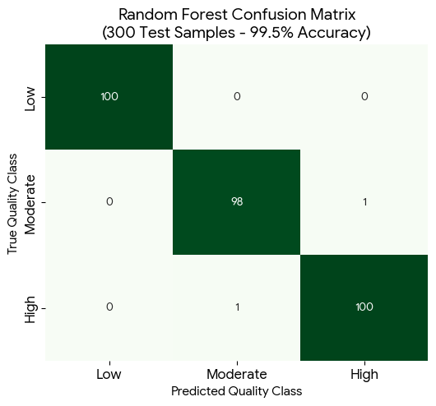
Figure 1: Model Evaluation

3.14.1 Performance Metrics
The Random Forest model’s evaluation demonstrates robust stability, yielding an overall accuracy of 99.5% with precision, recall, and F1-scores stabilizing at 0.99 across all targets. Looking closely at the classification matrix, the model achieved a 1.00 recall score for the 'Low' quality class.
From a public health and quality assurance perspective within Ugandan dairy nodes, this performance is vital. It proves that the prototype system can perfectly isolate high-risk or spoiled milk (Low Quality) without letting contamination bleed into clean processing streams. The minor classification errors (only 2 out of 300 instances) were restricted solely to borderline transitions between the 'Moderate' and 'High' tiers, presenting minimal operational risk to processing plants. Confusion-matrix analysis was also used to support interpretation of classification errors across the Low, Medium, and High categories.

Table 10: Random Forest Quality Classification Matrix (N = 1,500 Total)
Milk Quality Target | Precision | Recall | F1-Score | Test Support (N)
Low (Rejected) | 1.00 | 1.00 | 1.00 | 100
Moderate (Acceptable) | 0.99 | 0.99 | 0.99 | 99
High (Premium) | 0.99 | 0.99 | 0.99 | 101
Macro Average / Summary | 0.99 | 0.99 | 0.99 | 300 Test Samples
Global System Accuracy |  |  |  | 99.5%
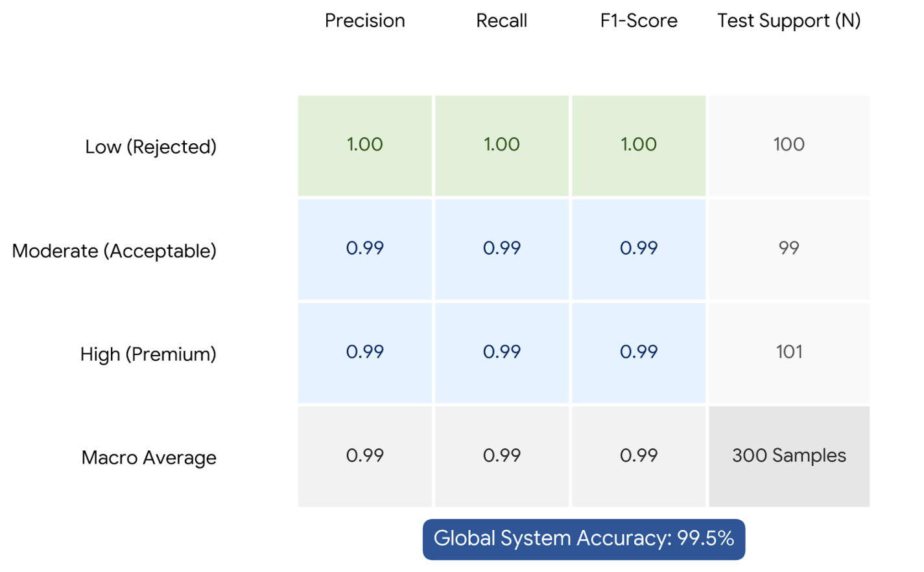
Figure 2: Random Forest Quality Classification Matrix

3.14.2 Cross-Validation
In the regard to make sure that this would have a more robust performance, the overfitting of machine learning models needs cross-validation. K-Fold Cross-Validation will be done where the data will be divided into K subsets or folds. The model will undergo training and testing K times with each fold being the test set once, while the other K-1 folds are for training. This will yield a more realistic estimation of the model performance because results across all folds are averaged. For example, using 5-fold cross-validation, a given dataset would be split into 5 subsets; then, 5 times, it trains the model and tests it using each subset once as a test set. This will help evaluate the ability of generalization and can make sure that the model generalizes well on different subsets, reducing the risk of overfitting.

3.15 Model Validation
Model validation focused on the consistency of classification outputs on the held-out test set and on comparison of model behavior with expected milk-quality interpretation derived from the available variables. The objective of validation was to ensure that the selected model produced coherent classification outcomes before integration into the prototype system.
In addition to reporting aggregate metrics, the study relied on confusion-matrix interpretation and scenario-based sample testing to examine how the classifier responded to different combinations of milk quality indicators. This validation approach supported the selection of Random Forest as the principal backend model for the prototype interface.

3.16 User Interface Development

3.16.1 Interface Design
The developed prototype DairyIQ is designed as a software decision-support dashboard for quality assurance personnel at milk reception points, standardizing evaluation speed.
The interface was designed to be intuitive and user-friendly for plant operators, ensuring ease of use and data accessibility. It featured a clear and organized layout, highlighting key features and functionalities. The interface was tested with plant operators for feedback and adjustments. Design principles like clear labeling, consistent color schemes, and intuitive icons were put into consideration. It is responsive and accessible across various devices, ensuring seamless interaction. Usability testing was done to ensure ease of understanding and navigation, shortening the learning curve for operators.
Visualizations like line graphs and bar charts were used in result output to help plant operators detect trends, patterns, and issues in the milk production process. The interface includes interactive features such as zooming and filtering for detailed investigation. Dashboards give an overview of key metrics like pH levels, bacterial counts, and temperature readings, alongside model predictions. These visualizations are clear and concise, enabling informed decision-making.

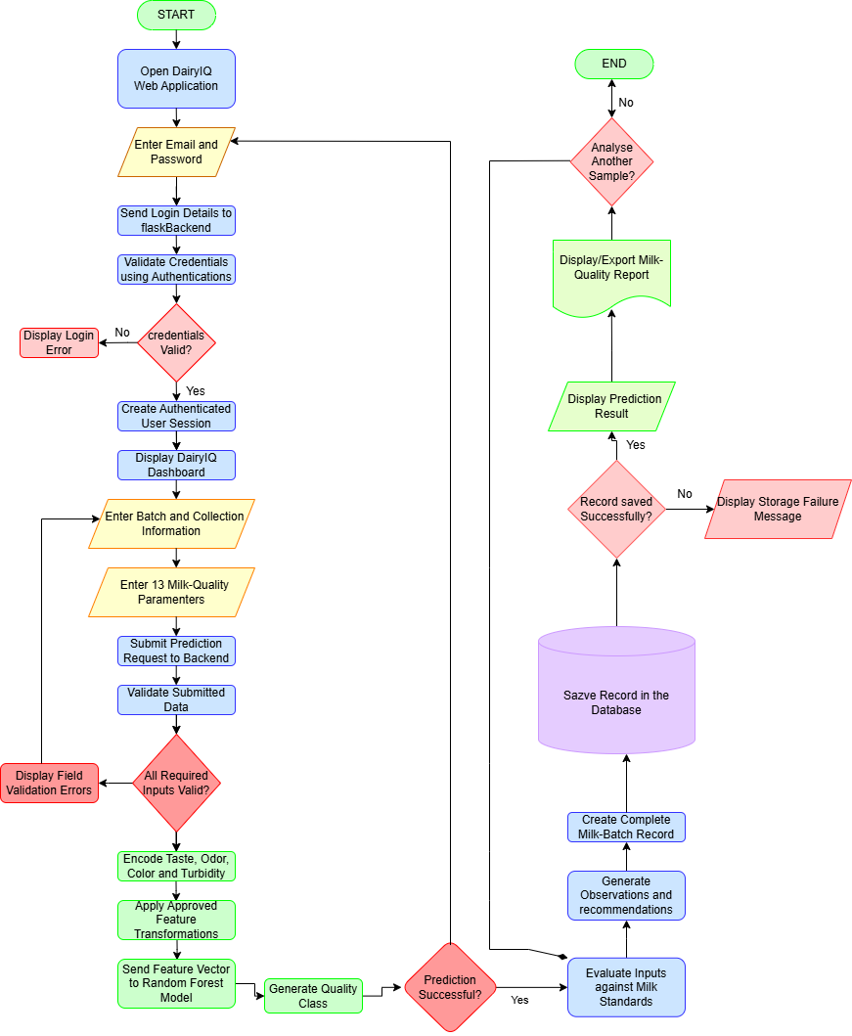
Figure 3: DairyIQ Data Flow Diagram

3.16.2 Implementation
The selected Random Forest model was integrated into a web-based prototype system. The implementation followed a manual input-to-classification workflow in which plant operators enter the relevant milk quality parameters and receive a classification output through the interface.
This implementation was designed as an interactive prototype rather than a live streaming system. The emphasis was therefore placed on usability, clarity of input fields, visual presentation of outputs, and practical support for routine milk quality decision-making in processing environments.
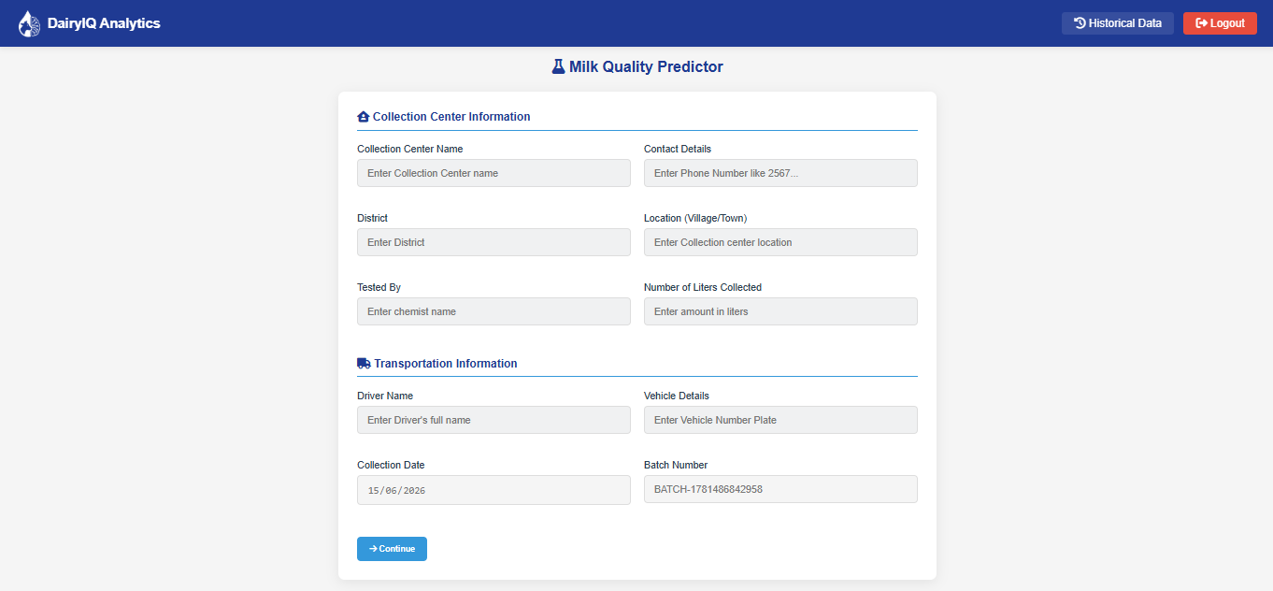

3.17 Technical Tools and Software

3.17.1 Data Processing Tools
The researcher used Pandas and NumPy for data manipulation and modeling, respectively.
Pandas was used to conduct the cleaning and manipulation activity through its DataFrames.
NumPy managed numerical computation and multi-dimensional arrays management. Scikit-learn implemented the development and training of machine learning models by providing a wide range of algorithms, along with associated tools to conduct evaluation and selection. It also combined these libraries in the pipeline for smooth processing and model development.
Visualization of data in readable and informative plots and charts was done using Matplotlib and Seaborn. Visualization with Matplotlib included all static, animations, and interactive visualizations, while complex visualizations with Seaborn were built on top of Matplotlib in order to portray the trending aspect in the data, model performance, and other metrics. The line graphs and bar charts were developed using Matplotlib; Seaborn will build up the heatmaps and scatter plots, depicting correlations of data and its pattern. This was then integrated onto the UI for concise insight into milk quality trends and model performance.

3.17.2 Machine Learning Frameworks
Scikit-learn was used to implement the main classification models considered in the study, including Random Forest, Support Vector Machine, and XGBoost. The library provided efficient tools for preprocessing, model training, hyperparameter tuning, and performance evaluation.
PyTorch supported the comparative Artificial Neural Network implementation, while joblib and related Python utilities were used for saving and loading trained models during prototype integration. Together, these frameworks enabled both experimental comparison and practical embedding of the selected classifier in a web-based interface.

3.17.3 User Interface Development:

User Interface Development
The user interface for DairyIQ was implemented as a web-based application to provide a platform-independent and scalable front end for the milk quality prediction system. By adopting a browser-accessible architecture, DairyIQ enables users to interact with the predictive model through standard web technologies. This architectural shift improves system portability, simplifies deployment, and supports centralized maintenance, as updates to the interface and application logic can be applied on the server side without requiring end-user reconfiguration.
From a functional perspective, the DairyIQ interface was designed to support the complete prediction workflow, including data entry, request submission, and presentation of model outputs. The interface accepts user-supplied milk quality parameters and transfers these inputs to the application layer, where they are processed and forwarded to the trained machine learning model for inference. The prediction results are then returned to the front end and displayed in a structured and interpretable format. This interaction model ensures a clear separation between the presentation layer, application logic, and predictive backend, thereby improving maintainability and extensibility of the overall system.
In addition, the DairyIQ interface was developed with responsive design principles to ensure consistent usability across different screen resolutions and device types. This is particularly important for practical deployment contexts in which the system may be accessed from office workstations, laboratory computers, or portable devices. The web-based layout therefore enhances accessibility while preserving functional consistency across operating environments.
Furthermore, DairyIQ incorporates dashboard-oriented visualization components to improve interpretability of prediction outcomes. These components present classification results and related analytical feedback in a visual form that supports rapid decision-making by users. Graphical representations of prediction results can assist operators in identifying milk quality trends, comparing output categories, and interpreting model behavior more effectively. Consequently, the web-based implementation of DairyIQ not only modernizes the delivery platform of the prototype but also strengthens the technical usability of the system as an interactive decision-support tool.

3.18. Limitation:
A major limitation of the study is the use of a synthesized dataset in place of real operational milk quality records. Although the dataset was constructed within recognized quality thresholds and therefore provided a legally grounded and contextually relevant basis for modeling, it may not fully capture the variability, noise and irregularities present in real-world dairy processing conditions. This limitation should be taken into account when interpreting the model’s performance and considering future deployment.

Chapter Four

RESULTS AND DISCUSSIONS

Introduction
This chapter presents the results of the study in line with the research objectives and discusses their implications for milk quality classification in Ugandan dairy processing environments. In this study, the empirical basis of the work shifted from plant-supplied records and generic secondary datasets to a standards-bounded dataset derived from East African raw cow milk quality requirements. This adjustment became necessary because the dairy processing plants approached for field data did not provide the required operational datasets, and the Kaggle dataset initially reviewed was not sufficiently localized to the Ugandan dairy context. Although useful for preliminary familiarization with machine learning workflow, the Kaggle data was not adopted as the principal basis for final model development and evaluation.
The final analytical framework therefore relied on a synthesized dataset designed around recognized East African milk quality thresholds EAS 67:2023 [n]. This provided a legally and scientifically defensible backbone for the synthesis of data and the development of the DairyIQ online prototype.
The chapter is organized according to the study objectives. It first presents the identified quality features and standards-derived parameter framework, then the Random Forest model results, and finally the implementation and demonstration of DairyIQ as a web-based prototype for milk quality decision support.

Objective One Results
Objective One sought to identify the key milk quality features required for classification of milk into defined quality categories. The results presented here are based on literature review, standards analysis, and the final standards-bounded data synthesis approach.

Results, Analysis, and Discussions from the Literature
The literature review and standards analysis converged on the conclusion that raw milk quality cannot be determined by a single attribute. Rather, it is a multidimensional construct involving physical, chemical, microbiological, and organoleptic parameters. In the Ugandan dairy context, this multidimensionality is particularly important because raw milk is often handled across variable transport conditions, inconsistent cold-chain infrastructure, and mixed formal-informal supply arrangements.
The literature consistently identifies pH, temperature, fat content, titratable acidity, microbial load, sensory quality, and udder-health-related indicators as major determinants of acceptability. These findings closely align with East African raw milk quality requirements. The publicly accessible EAS 67:2023 [n] provisions indicate that acceptable raw cow milk should contain at least 3.25% milk fat and at least 8.50% solids-not-fat, have a density of 1.028-1.036 g/ml at 20°C, and have titratable lactic acid not exceeding 0.17%. The same standard indicates that raw milk should have characteristic creamy-white color, be free from objectionable matter and off-flavors, not coagulate in the clot-on-boiling test, and test negative in the alcohol test. The microbiological grading framework further distinguishes milk by total plate count and somatic cell count.
The standards review also supported the use of pH as an interpretive parameter. The accessible annex indicates that normal cow milk is ordinarily around pH 6.6-6.8, while values above 6.9 may suggest abnormality such as mastitis or late lactation, and reduced pH may indicate developed acidity. These provisions were valuable because they provided an operational basis for converting quality science into machine-readable decision features.
Based on this evidence, the final study retained 11 predictive features: pH, temperature, fat content, titratable acidity, protein, lactose, total plate count (TPC), somatic cell count (SCC), taste, odor, and color. These variables were selected because together they represent the practical dimensions of quality assessment relevant to receiving platforms and laboratory-supported intake decisions. Protein and lactose were retained as compositional indicators that support the broader characterization of milk quality, even though the publicly accessible standard explicitly foregrounds fat, solids-not-fat, density, acidity, microbiology, and organoleptic acceptance criteria.
Table 4.1 summarizes the standards-derived parameter framework that informed the final dataset design and classification logic.

Table 11: Standards-derived framework for raw milk quality assessment
Parameter/Dimension | Standards indication used in this study | Relevance to classification
Milk fat | Not less than 3.25% | Low fat may suggest dilution or poor compositional quality
Solids-not-fat (contextual standard) | Not less than 8.50% | Used as interpretive standard context for acceptable raw milk composition
Density (contextual standard) | 1.028-1.036 g/ml at 20°C | Supports interpretation of normal composition and adulteration risk
Titratable acidity | Not more than 0.17% lactic acid | Higher acidity indicates deterioration and reduced processing suitability
pH | Normal milk around 6.6-6.8 | Deviations indicate possible spoilage or abnormal milk
Total plate count (TPC) | Low: <200,000/ml;  Moderate: >200,000-1,000,000/ml;  High: >1,000,000-2,000,000/ml | Major microbiological quality discriminator
Somatic cell count (SCC) | Not above 300,000/ml | Indicates udder health and hygienic quality
Color | Characteristic creamy-white | Used as organoleptic acceptability feature
Odor | Free from off-odors and taints | Used as organoleptic acceptability feature
Clot-on-boiling stability | Should not coagulate | Indicates suitability for processing
Alcohol test | Should test negative | Indicates heat stability and absence of abnormal milk
From the standpoint of feature identification, the literature and standards jointly demonstrated that milk quality classification in Uganda should be built around regionally relevant thresholds instead of imported generic assumptions. This was a crucial justification for the final methodological direction of the study.

Results from Data Collection
The data collection stage yielded an important methodological result: the anticipated field-based dataset could not be assembled from dairy processing plants. Despite efforts to obtain raw milk intake records and plant-level quality control data, the required datasets were not released to the researcher. This restricted direct access to localized operational records that would have enabled a fully empirical plant-by-plant model.
A secondary option involving a Kaggle dataset was reviewed during the early stages of the study.
However, that dataset was found unsuitable for the final study purpose for three main reasons.
First, it was not localized to the Ugandan dairy context. Second, its structure did not fully reflect the regional standards environment that governs raw milk acceptance in East Africa. Third, using it as the principal basis for final evaluation would have weakened the practical relevance of the study to Ugandan dairy processing plants. For these reasons, the Kaggle dataset was not used as the principal basis for the final model evaluation.
The final data approach therefore relied on a synthesized dataset bounded by East African raw milk quality requirements. A total of 1,500 samples were generated, deliberately balanced across three target classes: High quality (500), Moderate quality (500), and Low quality (500). This class balancing was intended to avoid model bias toward a dominant class and to provide sufficient representation of acceptable, borderline, and non-compliant milk conditions. The training-testing split was 80:20, yielding 1,200 training samples and 300 testing samples.
The class construction followed standards-informed logic. High quality observations represented values and sensory conditions consistent with acceptable raw milk for processing. Moderate quality observations represented borderline, mixed, or cautionary conditions that might require confirmatory checks or restricted handling. Low quality observations represented clearly non- compliant or poor-quality conditions, including abnormal acidity, elevated microbiological burden, poor sensory quality, or other combinations incompatible with routine acceptance.

Table 12: Final standards-bounded dataset composition
Dataset component | Value
Total synthesized samples | 1,500
High quality class | 500
Moderate quality class | 500
Low quality class | 500
Training set (80%) | 1,200
Testing set (20%) | 300
Number of predictive features | 11

The major result under Objective One, therefore, was not merely the identification of features, but the establishment of a defensible data foundation under constrained field conditions. In a context where plant data access proved difficult, the standards-bounded synthesis approach allowed the research to proceed while remaining aligned to regional quality regulation and the Ugandan dairy setting.

Objective Two Results
Objective Two sought to develop and evaluate a Random Forest model for milk quality classification using appropriate classification metrics.

Model Formulation and Design
The model formulation process transformed the identified milk quality dimensions into a structured supervised learning problem. The target variable was milk quality class with three labels: High, Moderate, and Low. The predictive feature space comprised 11 attributes: pH, temperature, fat content, titratable acidity, protein, lactose, TPC, SCC, taste, odor, and color.

Data preprocessing followed the approach described in Chapter Three. The categorical output classes were encoded for model training, and microbiological variables such as TPC and SCC were transformed logarithmically to stabilize scale differences and improve computational tractability. The train-test split was fixed at 80:20 to maintain consistency across model comparison experiments.
The Random Forest classifier was selected as the principal model because it is well suited to heterogeneous datasets containing both continuous and categorical-like decision inputs, and because it performs robustly in non-linear classification settings. The final model configuration used n_estimators = 100 and max_depth = 12, consistent with the methodological design of the study.
The standards-bounded nature of the dataset is especially important in interpreting the model design. The Random Forest model was not trained to reproduce arbitrary labels from a foreign dataset; rather, it was trained to recognize patterns grounded in regionally relevant quality thresholds. This made the resulting classification engine more suitable for decision support in Ugandan dairy processing environments than a model trained purely on externally sourced convenience data.
The prototype demonstrates the practical feasibility of converting a machine learning model into an accessible decision-support tool for dairy processing environments. In this, DairyIQ provides a useful proof of concept for how digital systems may support milk intake assessment, improve decision consistency and enhance the speed of preliminary quality screening.

Model Architecture
The model architecture combined standards-informed data preparation, supervised classification, and decision-support output generation. At the data layer, each milk sample was represented by the 11 selected quality features. At the model layer, the Random Forest classifier learned classification boundaries from multiple decision trees aggregated into an ensemble. At the application layer, the trained model was embedded into DairyIQ, an online web-based prototype accessible through a browser interface.
The architecture also supported comparative evaluation against alternative machine learning techniques. The study compared Random Forest with XGBoost, Artificial Neural Network (ANN), and Support Vector Machine (SVM). This comparison was necessary to justify the final selection of Random Forest not merely as a working algorithm, but as the most effective candidate among tested models under the present data conditions.
A key advantage of the architecture was interpretive alignment. Because the class labels were derived from standards-bounded threshold logic, the model outputs were intelligible to quality assurance personnel. A prediction of High, Moderate, or Low quality was not an abstract machine label; it corresponded to a compliance-oriented quality status with direct relevance to intake screening and handling decisions.

System Wireframes
The system design for DairyIQ reflected an online deployment model. The prototype was therefore conceptualized as a web-based decision-support platform that can be accessed through standard browsers on computers, tablets, or other internet-enabled devices available in dairy processing plants and milk collection settings.
The wireframe logic was organized around three functional areas. The first area was the input interface, where quality assurance personnel enter the observed or measured milk quality parameters. These include numeric fields for pH, temperature, fat content, titratable acidity, protein, lactose, TPC, and SCC, as well as selection fields for taste, odor, and color. The second area was the analytics and standards reference layer, which processes the submitted data through the trained Random Forest model while also reflecting the standards logic underlying the classification. The third area was the output dashboard, which presents the predicted quality class and a clear interpretation for action.
To support practical usability, the web-based interface was designed around simplicity and speed of use. The data entry form minimizes ambiguity, the classification result is prominently displayed, and the decision categories are color-coded for immediate recognition: green for High, amber for Moderate, and red for Low. Because the prototype is browser-accessible, it better reflects the current trend toward lightweight digital tools that can be deployed across dispersed dairy operations without requiring device-specific installation.

In discussion, a web-based prototype is significant. It increases the practical plausibility of adoption in Ugandan settings where different facilities may rely on shared devices, mobile connectivity, or cloud-based workflows. It also aligns with the study objective of producing a prototype system that can support milk quality assessment in operational environments.

Objective Three Results
Objective Three focused on applying the developed model within the DairyIQ prototype and evaluating its predictive performance and practical utility.

Parameters Used for Testing the Model
Testing of the model was conducted using the held-out test subset of 300 samples drawn from the final 1,500-record synthesized dataset. This ensured that evaluation was performed on previously unseen observations. The same 11 predictive features used in training were retained in testing to maintain consistency.
The testing framework reflected the standards-bounded data construction approach. Acceptable and non-acceptable patterns were represented across the High, Moderate, and Low classes using combinations of physical, chemical, microbiological, and sensory attributes. In this way, the evaluation tested not only whether the classifier could separate classes numerically, but whether it could do so in a way consistent with raw milk quality logic.
For clarity, Table 13 summarizes the principal model inputs used during testing.
Table 13: Features used in model testing
Feature | Type | Practical significance
pH | Numerical | Indicates normality or acidity development
Temperature | Numerical | Reflects handling and storage conditions
Fat content | Numerical | Compositional adequacy
Titratable acidity | Numerical | Stability and spoilage indicator
Protein | Numerical | Compositional support variable
Lactose | Numerical | Compositional support variable
TPC | Numerical (log-transformed) | Microbiological load
SCC | Numerical (log-transformed) | Udder health and hygienic quality
Taste | Categorical/encoded | Organoleptic acceptability
Odor | Categorical/encoded | Organoleptic acceptability
Color | Categorical/encoded | Organoleptic acceptability
The principal objective of testing was therefore to determine how effectively the Random Forest model could classify standards-bounded milk quality observations into the three classes and how it compared with alternative algorithms.

Validation of the Model
The validation results showed that the Random Forest model performed best among the tested classifiers. On the final test set, the Random Forest achieved 99.5% accuracy, with precision, recall, and F1-score each reported at 0.99. These values indicate that the model was highly effective at identifying the class structure embedded in the standards-bounded dataset. The comparative performance results are summarized in Table 4.4.

Table 14: Comparative performance of machine learning models
Model | Accuracy
Random Forest (RF) | 99.5%
XGBoost | 99.3%
Artificial Neural Network (ANN) | 98.2%
Support Vector Machine (SVM) | 91.6%

Table 15: Reported evaluation metrics for the Random Forest model
Metric | Value
Accuracy | 99.5%
Precision | 0.99
Recall | 0.99
F1-Score | 0.99

These results support the selection of Random Forest as the final predictive engine for DairyIQ.
The performance advantage, though modest over XGBoost, is meaningful because Random Forest also provides strong robustness under structured tabular data conditions and integrates efficiently into decision-support workflows.
From an interpretive standpoint, the high performance should be understood carefully. The model performed exceptionally well on the standards-bounded synthesized dataset used in this study. This demonstrates that Random Forest is highly capable of learning classification rules derived from East African raw milk quality thresholds. However, the results should not be mistaken for proof that the model has already been externally validated on large-scale operational datasets from multiple Ugandan plants. Such validation remains a future need and depends on improved data access.
The final validated model results presented here are those derived from the 1,500-sample standards-bounded dataset described in Chapter Three and operationalized in this revised chapter.

Code Snippets
At implementation level, the model logic followed the standard machine learning pipeline of preprocessing, training, serialization, and prediction serving within the online DairyIQ environment. The core logic can be summarized as follows:
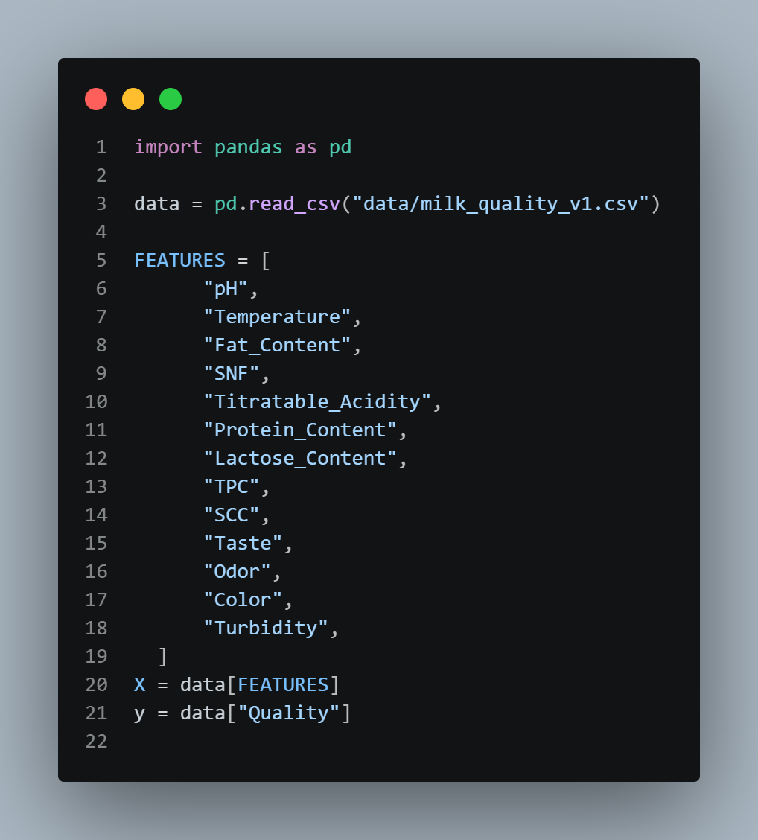
Figure 4: Data Loading and Feature Definition

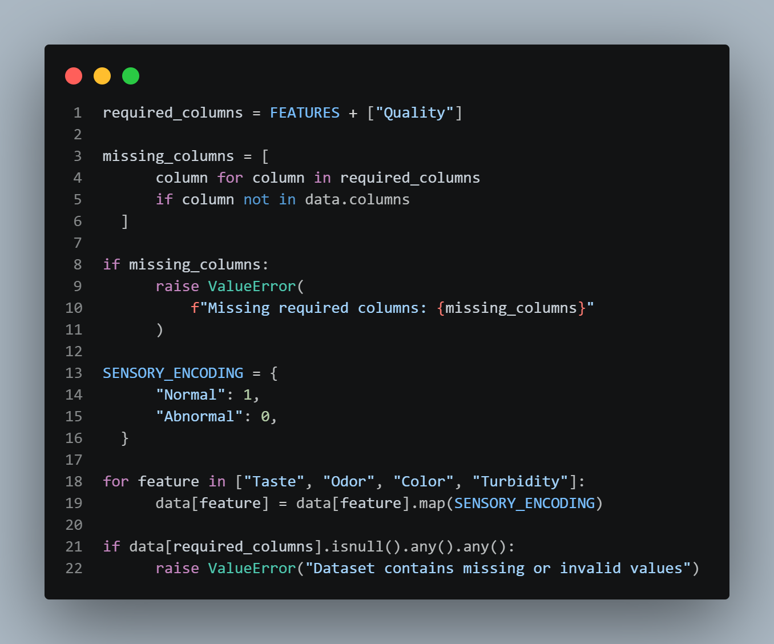
Figure 5: Data Validation and Sensory Encoding
For the web-based prototype, the trained model was connected to a browser-accessible input form. User-submitted values were validated, transformed into the same feature order used during training, and then passed to the predictive engine. The returned class was rendered immediately on the results dashboard.
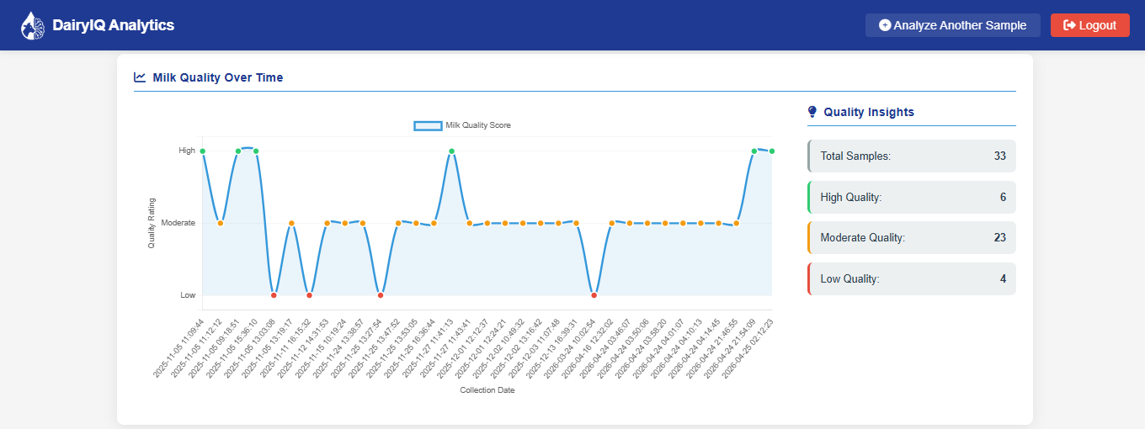
Figure 6: Results Graph
These implementation snippets are presented to show the logical structure of the system rather than to emphasize software syntax. The important result is that the predictive model was successfully operationalized in a web environment suitable for browser-based interaction. This marked a significant transition from algorithm development to usable prototype deployment.

System Demonstration With User Inputs and Outputs
The DairyIQ prototype was demonstrated using representative standards-informed input scenarios. In each case, a user enters milk quality parameter results from Laboratory through the web interface and submits the record for classification. The system then returns one of three outcomes: High, Moderate, or Low quality.
A scenario consistent with acceptable raw milk conditions produced a High-quality output. Such a case would typically involve pH within normal range, acceptable temperature handling, fat content at or above the minimum threshold, acceptable titratable acidity, good organoleptic condition, and microbiological indicators within favorable limits. The system output in such a case supports acceptance or priority processing.
A borderline scenario generated a Moderate-quality output. This type of case may arise where one or more parameters are near cautionary ranges even though the milk is not clearly failed on all indicators. In practical terms, this category is useful because it reflects the operational reality that some milk requires additional checking, conditional handling, or rapid processing rather than automatic acceptance or outright rejection.
A clearly non-compliant scenario produced a Low-quality output. Such a case may involve abnormal odor, suspicious color, elevated acidity, high TPC, SCC above acceptable limits, or combinations of poor-quality indicators. In these situations, the system provides an immediate warning that the milk presents quality risks for processing.
The system demonstration further showed that the web-based interface supports practical use. Data entry is sequential and comprehensible, the prediction is immediate, and the output format is understandable without requiring advanced technical knowledge from the user. Because the prototype is accessed through a browser, it is not tied to a single workstation or local installation environment. This improves deployment flexibility for milk collection centers and plant-based quality assurance points.
With regard to usability and practical applicability, the evidence generated in this study was qualitative rather than quantitative. No formal numerical usability survey scores or large participant test counts are reported here. This limitation was partly linked to the same access constraints that affected field data collection. Nevertheless, scenario-based demonstration showed that the prototype was logically coherent, operationally interpretable, and aligned to typical milk intake decision needs. The system therefore achieved proof-of-concept status as an online decision-support tool.
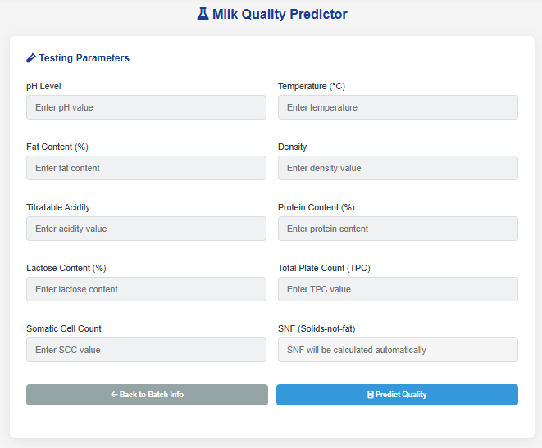
Figure 7: Parameter Data Inputs
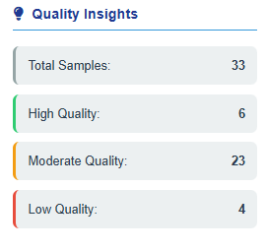
Figure 8: Sample Results

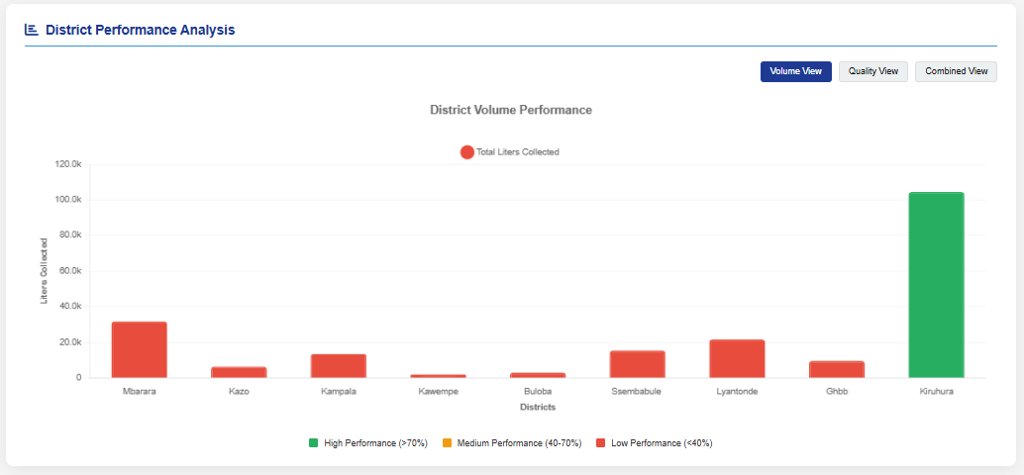
Figure 9: District Volume Performance
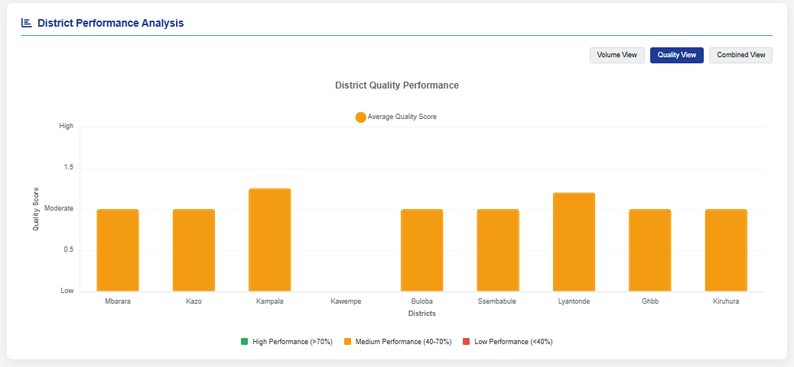
Figure 10: District Quality Performance
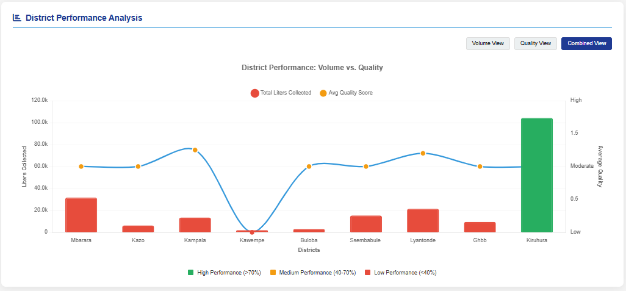
Figure 11: District Performance: Volume Vs. Quality

Operational Implications and Interventions
The results of this study have several important implications for the Ugandan dairy sector. First, the study shows that machine learning can be meaningfully aligned with regional standards even when direct plant data is difficult to obtain. In contexts where commercial sensitivity or poor digitization limits access to historical records, standards-bounded modeling offers a practical pathway for early-stage prototype development.
Second, the Random Forest model demonstrated that raw milk quality classification can be translated into a structured, repeatable, and fast digital decision process. This is particularly valuable in settings where intake decisions may otherwise rely heavily on fragmented manual checks or operator experience. The DairyIQ prototype does not replace laboratory testing or regulatory enforcement, but it can strengthen screening consistency and decision support.

Third, the study highlights the importance of standards harmonization in digital agriculture systems. By grounding the model in East African raw milk quality requirements, the prototype becomes more relevant to the regional regulatory environment than a model trained on unlocalized external data. This is critical for Uganda, where acceptance criteria should reflect the standards framework used by dairy operators, inspectors, and quality assurance teams.
Fourth, the online nature of the prototype expands its implementation potential. A browser- accessible tool can support quality screening across geographically distributed milk collection points and plants without requiring installation of specialized desktop software on every machine. This is especially relevant in operational environments where devices, staffing, and infrastructure may vary across locations.
Finally, the results indicate the need for stronger institutional collaboration around data access.
Future progress in this area depends on partnerships among dairy processors, regulators, and researchers to create responsibly governed datasets for model refinement and real-world validation. Without such collaboration, digital quality systems risk remaining promising prototypes rather than fully scaled operational tools.

Limitations
Despite the strong classification results obtained, the findings should be interpreted with caution because the model was evaluated on a standards-bounded synthesized dataset rather than real-time operational records from dairy plants. Consequently, the reported performance reflects proof-of-concept effectiveness within the modeled conditions and should be further validated using actual field or Laboratory data.

Chapter Five

Conclusion and Recommendation

Introduction
This chapter presents the overall discussion, conclusions, recommendations, and future directions of the study. It synthesizes the findings from the development and evaluation of the Random Forest model and the DairyIQ web-based prototype for milk quality classification in Ugandan dairy processing plants. The chapter also reflects on the methodological implications of conducting machine learning research under conditions of limited access to localized industry data.

Discussion

Synthesis of Findings
The study achieved its general objective of developing and evaluating a Random Forest model for milk quality classification and integrating it into a prototype system for use in the Ugandan dairy context. This was accomplished through a standards-bounded approach that aligned the analytical framework with East African raw cow milk quality requirements.
The first major finding was that the most relevant features for milk quality classification can be meaningfully identified by combining literature evidence with regional standards logic. The final feature set of 11 variables captured physical, chemical, microbiological, and organoleptic dimensions of milk quality. This supports the view that quality classification should not depend on isolated measurements alone.
The second major finding was methodological. Dairy processing plants did not provide the required field data, making it impossible to rely on plant-sourced records as originally intended. In addition, the Kaggle dataset reviewed during the study was found unsuitable as the principal basis for final model evaluation because it was not adequately localized to the Ugandan context and did not sufficiently reflect the standards environment relevant to East African raw milk acceptance.
These constraints led to the adoption of a synthesized dataset bounded by regional milk quality requirements. Rather than weakening the study, this shift enabled the development of a model grounded in a clearer regulatory and scientific framework.
The third major finding was that the Random Forest model performed exceptionally well on the final standards-bounded dataset. With an accuracy of 99.5% and precision, recall, and F1-score of 0.99, the model outperformed the compared alternatives of XGBoost, ANN, and SVM. This confirms that Random Forest is highly suitable for structured milk quality classification problems involving mixed feature types and non-linear relationships.

The fourth major finding was that the predictive model could be successfully embedded in DairyIQ as an online web-based prototype. This prototype translated the classification logic into a browser-accessible decision-support system capable of receiving user inputs and returning interpretable quality classes. The system demonstrated proof of concept for practical application in dairy processing plants and milk collection settings.
A further finding concerns standards interpretation. The study drew its accessible threshold backbone from the publicly available EAS 67:2006 raw cow milk specification, while acknowledging catalogue evidence showing EAS 67:2019 as the third edition and EAS 67:2023 [n] as the fourth edition replacing the 2019 edition. This careful positioning was necessary to avoid overstating access to proprietary or less publicly available editions while maintaining alignment with the regional standards lineage referenced in the dissertation.

Broader Implications
The broader implication of this study is that digital quality assurance in the dairy sector can be advanced even in settings where complete operational datasets are difficult to access. Standards-based data design offers a bridge between regulatory expectations and data-driven classification, especially in early-stage system development.
For Ugandan dairy processing plants, the study suggests that decision-support tools such as
DairyIQ can help standardize quality assessment at intake. In settings where manual judgment remains dominant, a web-based predictive system can improve consistency, speed, and documentation. This does not eliminate the need for laboratory confirmation or statutory inspection, but it can make preliminary screening more systematic.
For research and innovation, the study demonstrates that machine learning in agriculture should be context-sensitive. Models trained on convenient public datasets may achieve high technical accuracy while remaining poorly aligned to local realities. By contrast, a model grounded in East African raw milk quality requirements is more defensible for Ugandan application, even when it still requires further real-world validation.
For policy and sector development, the study underscores the importance of data governance and interoperability. If processors, regulators, and researchers establish better mechanisms for secure and ethical sharing of anonymized quality data, future models can move beyond standards-bounded synthesis toward increasingly robust field-validated decision systems.

Conclusion
This study concludes that Random Forest is an effective machine learning technique for classifying raw milk quality within a standards-oriented Ugandan dairy context. The model achieved the strongest performance among the tested algorithms and was successfully integrated into DairyIQ, a web-based prototype designed to support milk quality assessment.
The study also concludes that, under conditions where direct plant data is unavailable and generic secondary datasets are not sufficiently localized, a synthesized dataset bounded by East African raw milk quality standards provides a valid and practical research pathway. The accessible raw milk specification provisions relating to fat content, acidity, microbiological grades, somatic cell count, pH interpretation, and organoleptic acceptability offered a strong basis for structuring the classification problem.
At the same time, the study recognizes its limits. The reported model performance reflects validation on a standards-bounded synthesized dataset rather than large-scale live operational data from dairy plants. Consequently, the findings establish proof of concept and strong methodological promise rather than final sector-wide deployment readiness. Even so, the study makes an important contribution by demonstrating that standards-informed artificial intelligence can be translated into an accessible decision-support prototype for the dairy industry in Uganda.

Experiences and Skills Gained

Technical Skills

The study strengthened technical skills in data preparation, supervised machine learning, model evaluation, and prototype system development. Specific competencies gained included feature engineering, preprocessing of mixed-type datasets, class-balanced dataset design, use of Random Forest and comparator models, and evaluation using accuracy, precision, recall, and F1-score. The work also developed practical understanding of how predictive models can be integrated into a web-based interface for end-user interaction.
In addition, the study enhanced skills in translating domain standards into machine-readable logic. This was particularly important because the final dataset design depended on interpreting quality thresholds and incorporating them into a usable classification framework.

Research and Analytical Skills
The research process improved skills in problem reformulation, methodological adaptation, and critical source evaluation. When field data could not be obtained and the Kaggle dataset proved unsuitable for the Ugandan context, the study required a careful redesign that remained academically rigorous. This strengthened the ability to align research design with real-world constraints without losing coherence.
The study also deepened analytical skills in interpreting standards documents, comparing algorithmic performance, and discussing findings in relation to sector-specific realities. More broadly, it reinforced the importance of context in applied artificial intelligence research.

Recommendations
Based on the findings of this study, the following recommendations are made.
First, dairy processing plants and milk collection operators should consider gradual adoption of digital intake support tools such as DairyIQ to complement existing quality checks. A web-based system is particularly appropriate because it can be accessed through standard browsers and can support distributed operations without heavy installation requirements.
Second, quality assurance workflows should be aligned more explicitly with East African raw milk quality standards. Digital systems intended for the Ugandan dairy sector should be built around recognized regional thresholds rather than relying primarily on foreign or generic datasets.
Third, regulators and sector institutions should encourage structured, anonymized data-sharing arrangements for research and innovation. The inability to access plant-level data was one of the main constraints of this study. Improved access to ethically managed operational datasets would enable stronger validation and more refined models.
Fourth, future deployment of DairyIQ should be accompanied by pilot implementation in real dairy environments. Such pilots would allow comparison between model outputs, laboratory findings, and operator decisions, thereby strengthening confidence in practical applicability.
Fifth, any operational version of the prototype should remain updated against the most current applicable standard. Since catalogue evidence indicates a progression from EAS 67:2006 to EAS 67:2019 and subsequently to EAS 67:2023 [n], implementers should confirm the current enforceable edition and harmonize the decision rules accordingly.
Sixth, digital milk quality systems should be designed to support, not replace, professional judgment and laboratory testing. The role of the model is best understood as rapid screening and decision support at intake rather than final statutory certification.

Future Work
Future work should focus on external validation of the model using real operational data from Ugandan dairy processing plants, milk collection centers, and related quality assurance environments. This is the most important next step for strengthening the evidence base of the prototype.
Further research should also examine how the model performs when additional standards-related variables such as solids-not-fat, density, and freezing point are incorporated directly into the predictive feature set. This would deepen the linkage between regulatory standards and machine learning classification.
A second area is usability evaluation. Future studies should undertake structured field trials with actual users in dairy plants and collection settings, generating systematic evidence on ease of use, decision time, trust, and operational fit.
Finally, future work should track standard revisions carefully. Since the standards lineage has continued beyond the publicly accessible 2019 edition, subsequent model refinement should verify and incorporate any materially updated thresholds in the latest applicable East African raw cow milk specification.

Reference
[1] T. Abass, E. O. Itua, T. Bature, and M. A. Eruaga, “Concept paper: Enhancing milk quality in Uganda: Challenges and innovations in the dairy value chain,” 2024.

[2] F. Açıkgöz, L. Vercin, and G. Erdoğan, “A literature review on machine learning in the food industry,” Alphanumeric Journal, vol. 11, no. 2, pp. 207–222, 2023.

[3] E. Ahikiriza, J. Wesana, X. Gellynck, G. Van Huylenbroeck, and L. Lauwers, “Context specificity and time dependency in classifying Sub-Saharan Africa dairy cattle farmers for targeted extension farm advice: The case of Uganda,” Agriculture, vol. 11, no. 9, p. 836, 2021, doi: 10.3390/agriculture11090836.

[4] R. Ariong, B. Van Campenhout, S. W. Kariuki, and J. Chamberlin, “Accuracy when defining milk quality classification,” in 2023: Seven Congress, 2023.

[5] A.-M. Ariton et al., “Nondestructive methods for milk quality assessment,” Scientific Papers Journal, Veterinary Series, vol. 65, no. 4, pp. 40–46, 2022.

[6] D. Bhavsar, Y. Jobanputra, N. K. Swain, and D. Swain, “Milk quality prediction using machine learning,” EAI Endorsed Transactions on Internet of Things, vol. 10, 2023.

[7] C. Burke, “Progress and challenges to Uganda’s dairy sector,” Dec. 2020. [Online]. Available: https://www.theigc.org/sites/default/files/2020/12/Progress-and-challenges-to-Ugandas-dairy-sector.pdf

[8] A. Çelik, “Using machine learning algorithms to detect milk quality,” Eurasian Journal of Food Science and Technology, vol. 6, no. 2, pp. 76–87, Dec. 2022.

[9] T. Chen and C. Guestrin, “XGBoost: A scalable tree boosting system,” in Proc. 22nd ACM SIGKDD Int. Conf. Knowledge Discovery and Data Mining, 2016, pp. 785–794.

[10] K. B. Chhetri, “Applications of artificial intelligence and machine learning in food quality control and safety assessment,” Food Engineering Reviews, vol. 16, no. 1, pp. 1–21, Mar. 2024.

[11] M. H. L. Cunha and H. S. Lara, “Innovative approaches to food quality control: AI and machine learning for predictive analysis,” World Journal of Advanced Research and Reviews, vol. 21, no. 3, pp. 823–828, 2024.

[12] Dairy Development Authority, “DDA annual report – FY 2022–2023,” 2023. [Online]. Available: https://dda.go.ug/images/1705390472.pdf

[13] J. Ekou, “Dairy production and marketing in Uganda: Current status, constraints and way forward,” African Journal of Agricultural Research, vol. 9, no. 10, pp. 881–888, 2014, doi: 10.5897/AJAR2013.8038.

[14] Food and Agriculture Organization of the United Nations, A Review of Uganda’s Dairy Industry, D. Balikowa, Ed. 2011. [Online]. Available: http://www.fao.org/4/aq292e/aq292e00.pdf

[15] P. Grimaud, M. L. Sserunjogi, and N. Grillet, “An evaluation of milk quality in Uganda: Value chain assessment and recommendations,” African Journal of Food, Agriculture, Nutrition and Development, vol. 7, no. 5, pp. 1–16, 2007, doi: 10.18697/ajfand.16.2625.

[16] Y. Liu et al., “Understanding LLMs: A comprehensive overview from training to inference,” arXiv preprint arXiv:2401.02038, 2024.

[17] R. Moore, “The science of milk: Fundamentals of dairy processing,” 2024. [Online]. Available: https://husfarm.com/article/the-science-of-milk-fundamentals-of-dairy-processing

[18] H. Moradi, M. Sedaghati, and N. Jahanbakhshian, “Evaluation and improvement of antioxidant activity and physicochemical properties of yogurt enriched with Persian gum (Amygdalus scoparia Spach) and fennel (Foeniculum vulgare) extract,” Acta Scientiarum Polonorum Technologia Alimentaria, vol. 22, no. 4, pp. 431–440, 2023, doi: 10.17306/j.afs.1163.

[19] F. Mu, Y. Gu, J. Zhang, and L. Zhang, “Milk source identification and milk quality estimation using an electronic nose and machine learning techniques,” Sensors, vol. 20, no. 15, p. 4238, 2020.

[20] S. Nyokabi, P. A. Luning, I. J. M. de Boer, L. Korir, E. Muunda, B. O. Bebe, J. Lindahl, B. Bett, and S. J. Oosting, “Milk quality and hygiene: Knowledge, attitudes and practices of smallholder dairy farmers in central Kenya,” Food Control, vol. 130, Art. no. 108303, 2021, doi: 10.1016/j.foodcont.2021.108303.

[21] A. Samad, S. Taze, and M. Ucar, “Enhancing milk quality detection with machine learning: A comparative analysis of KNN and distance-weighted KNN algorithms,” International Journal of Innovative Science and Research Technology, vol. 9, no. 3, 2024.

[22] I. H. Sarker, “Machine learning: Algorithms, real-world applications and research directions,” SN Computer Science, vol. 2, no. 3, 2021.

[23] A. Shahzad, S. Javaid, and Z. Alamsyah, “Milk quality detection using machine learning,” Engineering Proceedings, vol. 107, no. 1, p. 119, 2025, doi: 10.3390/engproc2025107119.

[24] P. Shine and M. D. Murphy, “Over 20 years of machine learning applications on dairy farms: A comprehensive mapping study,” Sensors, vol. 22, no. 1, p. 52, 2022, doi: 10.3390/s22010052.

[25] D. Ssekibaala, “Assessment of the factors influencing milk production among smallholder dairy farmers in Nakasongola District,” unpublished bachelor’s dissertation, Makerere Univ., 2019.

[26] Y. Sugino, J. Bugeza, D. Bahame, J. Byaruhanga, H. Shimazaki, M. Anzai, T. Kayano, W. Mwebembezi, A. Akashaba, T. Shimada, Y. Muramatsu, and K. Makita, “Structure and milk hygiene of dairy cooperative value chains in an intensive production area of Uganda—A bottleneck of intervention,” Frontiers in Sustainable Food Systems, vol. 7, 2023, doi: 10.3389/fsufs.2023.1110915.

[27] V. Zatsu et al., “Revolutionizing the food industry: The transformative power of artificial intelligence - a review,” Food Chemistry: X, vol. 24, Art. no. 101867, Dec. 2024.

[n] East African Community, Raw cow milk—Specification, EAS 67:2023, 4th ed., 2023.

